**SENTIMENT ANALYSIS**

**LUXURY CARS REVIEWS**

Mahmoud Al Hamad 1010767



|  |  |
| --- | --- |
| **Student Name(s)** | Mahmoud Al Hamad |
| **Consulted Tutor** | Sini Rag Pulari |
| **Subject** | NLP |
| **Github** | <https://github.com/Alhamad-Mahmoud/IT9002-NLP-Project> |

# TABLE OF CONTENTS

PROBLEM STATEMENT DEFINITION …………………………………………………………. 4

0.1 Motivation

0.2 Problem Statement

0.3 Proposed Solution

0.4 Implementation and Impact

0.5 Expected Result

1. LIBRARIES NEEDED IN THE PROJECT ……………………………………………………………………… 6
   1. User Defined Functions …………………………………………………………. 8
2. DATA COLLECTION
   1. Context …………………………………………………………………………….10
   2. About the Features ……………………………………………………………….11
   3. Target Variable …………………………………………………………………….12
3. ANALYSIS
   1. Reading the Data ………………………………………………………………….13
4. EXPLORATORY DATA & VISUALIZATION
   1. A General Looking at the Data ………………………………………………….14
   2. Examination of Target Variable ………………………………………………….19
   3. Examination of Other Features ………………………………………………….22

5) TEXT PREPROCESSING

* 1. Feature Selection …………………………………………………………………33
  2. Dealing With Missing Values ……………………………………………………34

6) TEXT PREPROCESSING ………………………………………………………………………36

* 1. Tokenization ……………………………………………………………………….37
  2. Noise Removal …………………………………………………………………....38
  3. Stemming ………………………………………………………………………….39
  4. Lemmatization …………………………………………………………………….40
  5. Handling With Rare Words ………………………………………………………41

7) TEXT REPRESENTATION ……………………………………………………………………...44

* 1. The Detection of Positive and Negative Reviews ……………………………………44
  2. The Collection of Positive and Negative Words …………………………………….46
  3. Creating of Word Cloud …………………………………………………………………47
  4. Part Of Speech Tagging ……………………………………………………………….49
  5. Named Entity Recognition …………………………………………………………….51
  6. Word Embeddings ………………………………………………………………………51
  7. Bag of Words ……………………………………………………………………………52

1. SENTIMENT CLASSIFICATION WITH MACHINE LEARNING & DEEP LEARNING …55
   1. Train | Test & Split ……………………………………………………………………….56
   2. Vectorization …………………………………………………………………………….56
      1. Count Vectorization ……………………………………………………………….57
      2. TF-IDF Vectorization …………………………………………………………...…58
2. MACHINE LEARNING MODELLING
   1. Naive Bayes ……………………………………………………………………………...60
      1. Naive Bayes With Count Vectorizer …………………………………………….60
      2. Naive Bayes With TF-IDF Vectorizer…………………………………………….65
   2. Support Vector Machine (SVM) ……………………………………………………….68
      1. (SVM) With Count Vectorizer ……………………………………………………68
      2. (SVM) With TF-IDF Vectorizer ………………………………………………….70

10) DEEP LEARNING MODELLING ………………………………………………………………72

* 1. Tokenization …………………………………………………………………………….73
  2. Creating Word Index……………………………………………………………………73
  3. Converting Tokens To Numeric……………………………………………………….74
  4. The Determination of Maximum Number of Tokens ……………………………….75
  5. Fixing Token Counts of All documents (Pad Sequences) ………………………….76
  6. Train | Set & Split ……………………………………………………………………….77
  7. 10.7 Modeling ……………………………………………………………………….…78

10.8 Model Evaluation ……………………………………………………………………….80

1. PREDICTION …………………………………………………………………………………83
2. THE COMPARISON OF MODELS …………………………………………………………85
3. CONLUSION ………………………………………………………………………………….88
4. RECOMMINDATION …………………………………………………………………………89

15) REFERENCES ……………………………………………………………………………….90

# PROBLEM STATEMENT DEFINITION

This Sentiment Analysis and Classification Project focuses on utilizing Natural Language Processing (NLP) techniques to analyze customer reviews. The primary objective is to predict whether customers recommend the purchased product based on the information in their review text.

Key challenges include extracting valuable information from the "Review" variable using text mining techniques and converting text files into numeric feature vectors for machine learning algorithms.

The project covers a comprehensive exploration of the dataset through detailed Exploratory Data Analysis (EDA) and visualization. It also involves building sentiment classification models using machine learning algorithms (Naive Bayes, Support Vector Machine) and deep learning algorithms.

MOTIVATION

The project's significance lies in its pivotal role within the automotive industry, where analyzing customer reviews can shape the trajectory of brand reputation and market competitiveness.

By predicting customer recommendations based on reviews, the project offers actionable insights, enabling manufacturers to refine product offerings and enhance service quality. This approach contributes to the advancement of Natural Language Processing (NLP) methodologies, showcasing the application of sophisticated techniques for sentiment analysis on extensive datasets.

Beyond the automotive domain, the societal impact is evident as the project fosters transparency in consumer decision-making, ensuring accurate sentiment predictions for informed choices. The outcomes of this endeavor hold potential to transform not only how manufacturers perceive customer satisfaction but also how consumers navigate a marketplace increasingly influenced by online reviews.

PROBLEM STATEMENT

The project addresses the challenge of effectively analyzing automotive customer reviews, aiming to predict recommendations based on Edmunds-Consumer Car Ratings. Extracting meaningful insights from textual reviews is crucial for understanding consumer sentiments and influencing purchasing decisions in the automotive industry.

PROPOSED SOLUTION

The solution leverages NLP techniques like text mining, employing machine learning (Naive Bayes, SVM) and deep learning algorithms. By combining these approaches, the project aims to build robust sentiment classification models that enhance the accuracy of predicting customer recommendations, providing valuable insights for manufacturers to improve their products.

IMPLEMENTATION and IMPACT

The solution's implementation involves in-depth Exploratory Data Analysis (EDA) and visualization, ensuring a comprehensive understanding of the dataset's features. This project not only contributes to NLP advancements but also has the potential to reshape feedback analysis in the automotive industry. The informed decision-making facilitated by this approach holds significance for both consumers and manufacturers, impacting the industry's feedback analysis processes.

# 1) LIBRARIES NEEDED IN THE PROJECT

various Python libraries for data analysis, visualization, and machine learning used in this report. Here's a brief overview of the major libraries used:

NumPy (np): Fundamental package for scientific computing with support for large, multidimensional arrays and matrices.

Pandas (pd): Provides data structures like DataFrame for efficient data manipulation and analysis.

Seaborn (sns) and Matplotlib (plt): Data visualization libraries for creating attractive and informative statistical graphics.

Re (re): Regular expression operations for string manipulation.

Plotly Express (px) and Graph Objects (go): Interactive plotting libraries for creating visually appealing plots and graphs.

SciPy Stats (stats): Library for scientific and technical computing, including statistical functions.

StatsModels (sm) and Formula API (smf): Provides classes and functions for statistical models’ estimation.

Scikit-Learn (sklearn): A machine learning library that includes various classification and model selection tools.

NLTK (nltk): Natural Language Toolkit for working with human language data. It includes tokenization, stemming, lemmatization, and more.

WordCloud: Generates word clouds, visual representations of word frequency in a given text.

Yellowbrick: Visualization library that extends Scikit-Learn to provide visual diagnostic tools.

Cufflinks (cf): Connects Plotly with Pandas for interactive visualizations in offline mode.

Warnings (warnings): Provides control over warning messages in Python.

IPyWidgets (ipywidgets): Interactive HTML widgets for Jupyter notebooks.

Termcolor and Colorama: Libraries for adding color to terminal text for better readability.

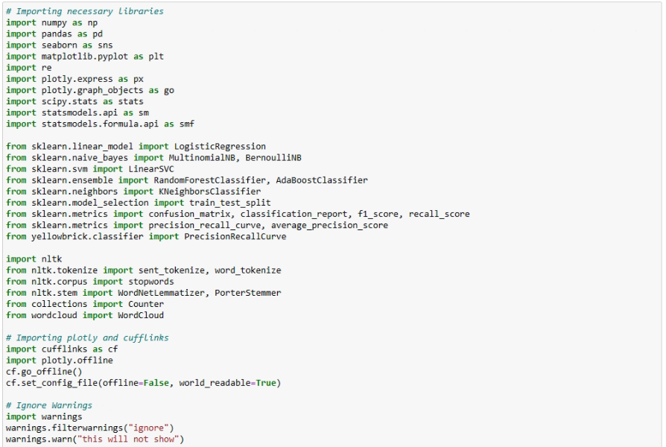

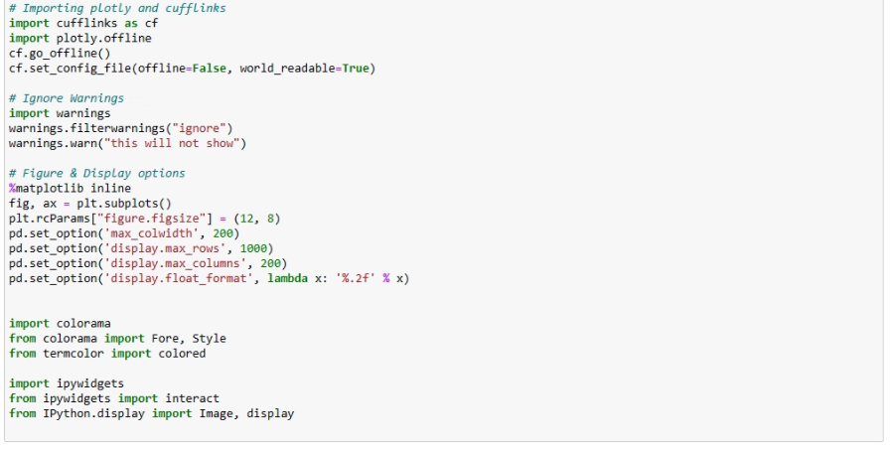

## 1.1 User Defined Function

**I have defined some useful user defined functions.** 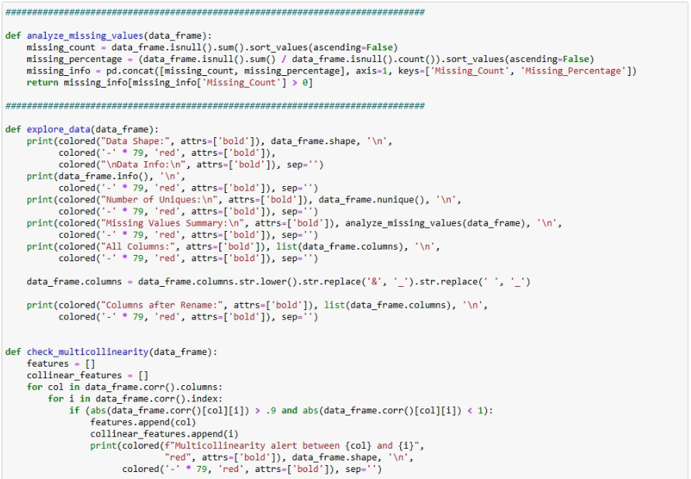

# 

# 2) DATA COLLECTION

## 2.1 Context

This is a dataset containing consumer's thought and the star rating of car manufacturer/model/type.

Why i select this dataset:

Currently, this dataset has data of 62 major brands. i only focus for my project on luxury car reviews within the dataset. By narrowing down the scope to luxury cars, i can delve deeper into understanding consumer sentiments, preferences, and experiences specific to high-end automotive brands. This targeted approach allows for more meaningful insights and analysis, particularly within the luxury car market segment.

Vehicles stand as a significant element of personal identity, reflecting one's preferences and lifestyle. The reviews provided by customers offer a glimpse into their experiences with different car models.

In this context, the basic goal of this project is to predict whether customers, especially assumed as man, recommend the car they purchased using the information in their *review*. Especially, it should be noted that the expectation in this project is to use only the "review" variable and neglect the other ones. Of course,

The data is a collection of 55165 Rows and 10 column variables. Each row includes a written comment as well as additional customer information. Also each row corresponds to a customer review, and includes the variables.

Dataset srouce :[https://www.kaggle.com/datasets/ankkur13/edmundsconsumer-car-ratings-andreviews/data (https://www.kaggle.com/datasets/ankkur13/edmundsconsumer-car-ratings-andreviews/data)](https://www.kaggle.com/datasets/ankkur13/edmundsconsumer-car-ratings-and-reviews/data)

## 2.2 About the Features

The dataset encompasses various features, including temporal aspects, author details, age distribution, vehicle make, model specifics, review titles, and ratings. These features offer a comprehensive view, enabling analyses ranging from sentiment trends to customer satisfaction and binary classification tasks based on vehicle recommendations.

**1) review_date (Categorical - Temporal): This column provides the timestamp of each review. Analyzing this data could reveal patterns related to when reviews are posted, potential seasonality, or trends over time.

**2) author_name (Categorical - Text): Contains the names of the individuals providing reviews. This information can be used to identify frequent reviewers, trends related to specific authors, or even sentiment analysis based on the author.

**3) age (Numerical - Continuous): Represents the age of the authors. Analyzing the distribution of ages can provide insights into the age groups that are more likely to review, and potential correlations between age and the given ratings

**4) vehicle_make (Categorical - Text): Specifies the make or brand of the vehicle being reviewed (e.g., Ferrari). This can be used to understand which vehicle brands are more popular or receive more reviews.

**5) vehicle_title (Categorical - Text): Provides information about the specific model or configuration of the vehicle. Analyzing this column can reveal which models are more frequently reviewed and the sentiments associated with them. **6) review_title: Categorical (Text) - Title given to the review.

**7) review_title (Categorical - Text): The titles given to the reviews. Analyzing these titles might give an overview of the reviewers' initial impressions or the main points of their reviews.

**8) rating (Numerical - Discrete): Numeric ratings assigned to the vehicles. Analyzing the distribution of ratings provides insights into the overall satisfaction of customers.

**9) recommended_ind (Categorical - Binary): Indicates whether the author recommends the vehicle (1) or not (0). This column is crucial for understanding customer satisfaction and can be used for binary classification tasks.

## 2.3 Target Variable

* In my project, the target variable is typically the sentiment label assigned to a piece of text "recommended_ind". Sentiment labels indicate the emotional tone expressed in the text it is type is binary (positive/negative)

# 3) ANALYSIS

## 3.1 Reading the Data

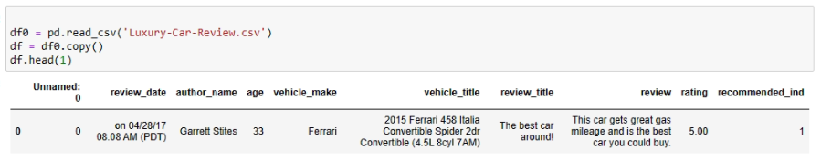

# 4) EXPLORATORY DATA &VISUALIZATION

## 4.1 - A General Looking at the Data

Pandas profiling is an open source Python module with which we can quickly do an exploratory data analysis with just a few lines of code.

The function, explore_data performs an initial exploration of a DataFrame (df). Here's a breakdown of what the function does:

**Display Shape and Info:**

Prints the shape of the DataFrame. Prints information about the DataFrame using df.info().

**Display Number of Uniques:**

Prints the number of unique values for each column in the DataFrame.

**Display Missing Values:**

Prints information about missing values in the DataFrame using the missing_values function (which is assumed to be defined elsewhere).

**Display All Columns:**

Prints the names of all columns in the DataFrame.

**Rename Columns:**

Converts column names to lowercase. Replaces spaces with underscores. Replaces the ampersand (&) with an underscore. Display Columns after Rename:

Prints the names of all columns after the renaming process.

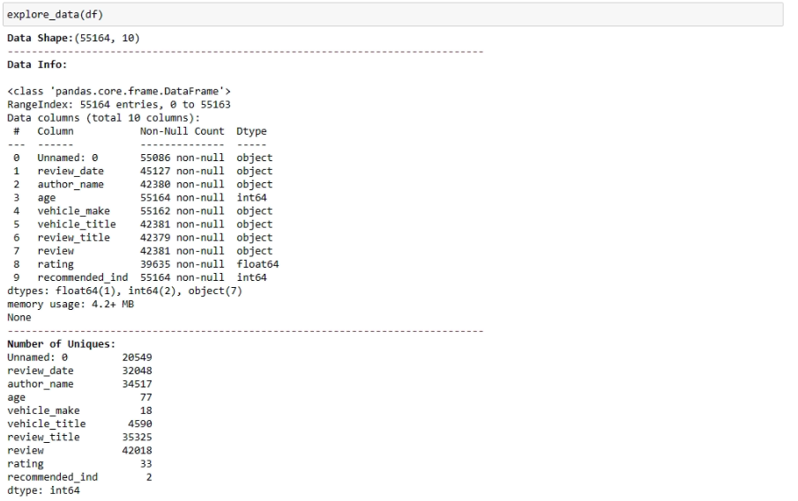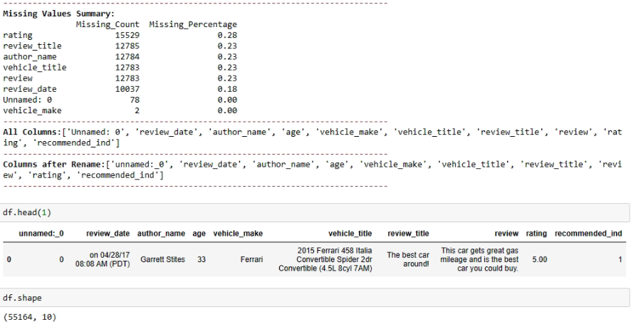

* Initially Data set Contains 55164 Rows and 10 colom
* I want to drop a column named "unnamed:_0" from my DataFram

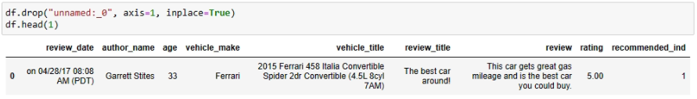

* Producing a visually appealing representation of the summary statistics with a background gradient

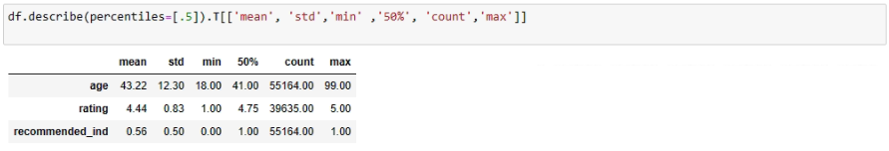

* generating descriptive statistics of the object (categorical) columns in a DataFrame. It provides information such as the count, unique values, top value, and frequency for each categorical column.

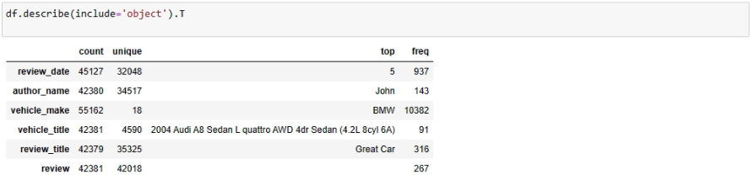

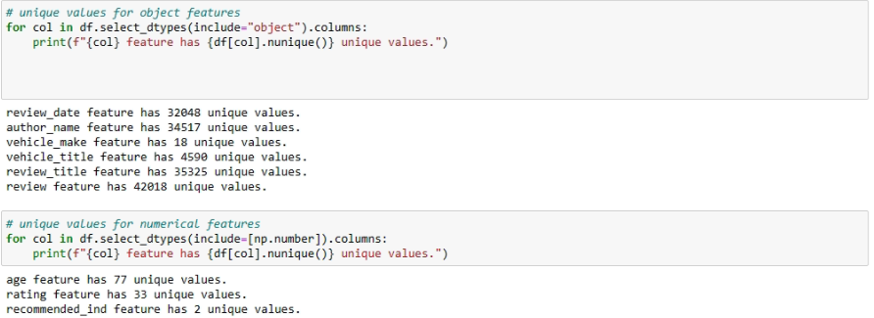

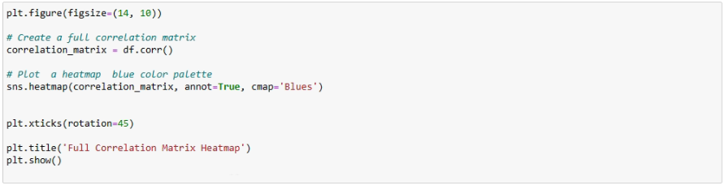

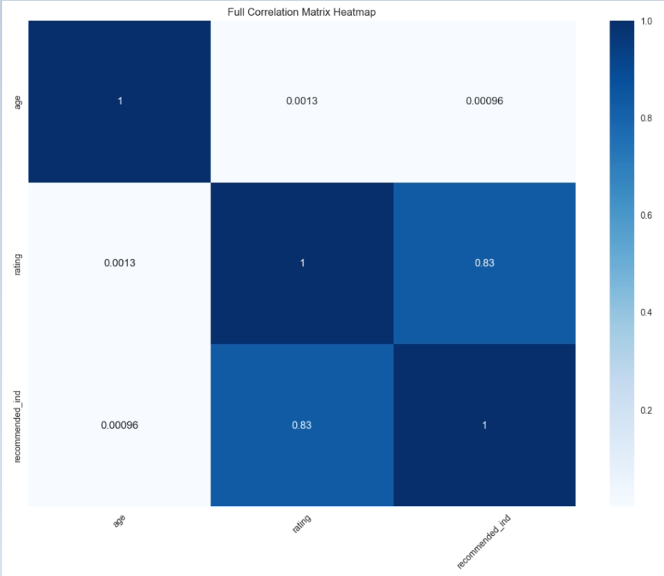

* the correlation coefficients between different pairs of variables in a DataFrame. Here's how to interpret it:
* age vs. age: The correlation of a variable with itself is always 1. So, the correlation between 'age' and 'age' is 1.
* age vs. rating: The correlation coefficient between 'age' and 'rating' is 0.0013. This value is close to zero, indicating a very weak or negligible linear correlation between the age of the reviewers and the ratings they give.
* age vs. recommended_ind: The correlation coefficient between 'age' and
* 'recommended_ind' is 0.00096. Similar to the previous case, this value is close to zero, suggesting a very weak or negligible linear correlation between age and the recommendation indicator.

## 4.2 - The Examination of Target Variable

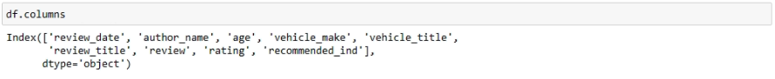

* Check Proportion of Target Class Variable:
* The target class variable is imbalanced, where "Recommended" values are more dominating then "Not Recommended".

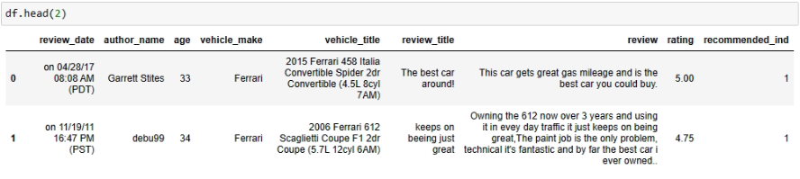

The Examination of "recommended_ind" Variable

"recommended_ind" is a binary variable stating where the customer recommends the product where 1 is recommended, 0 is not recommended.This information provides a distribution of the binary values in the "recommended_ind" column. It seems that there are more occurrences of value 1 than value 0. In a binary classification context, this could imply that the dataset is somewhat imbalanced, with more instances of positive recommendations (1) than negative recommendations (0).

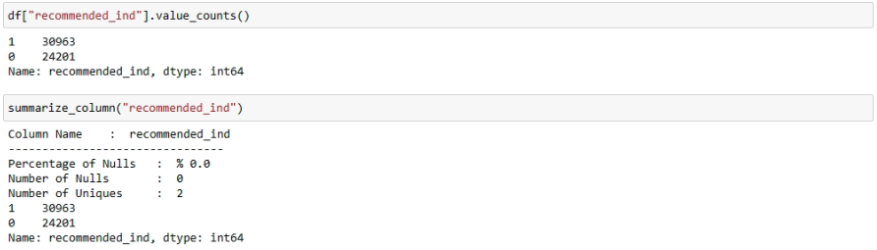

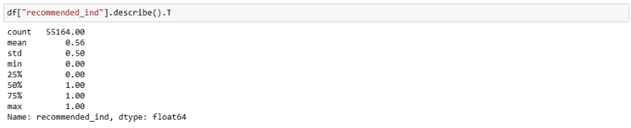

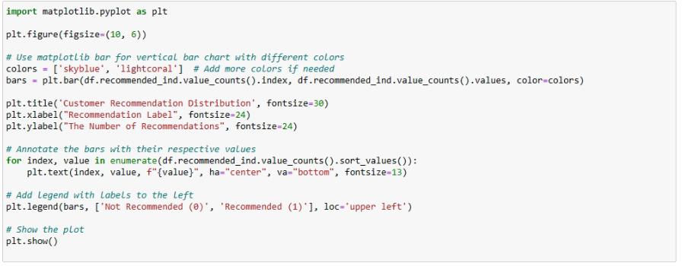

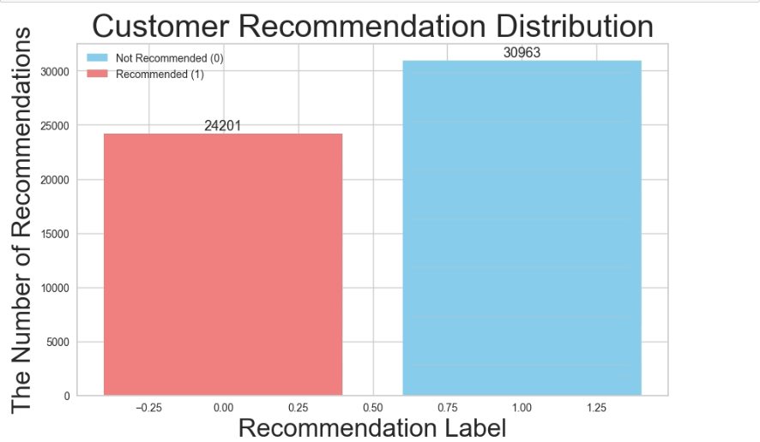

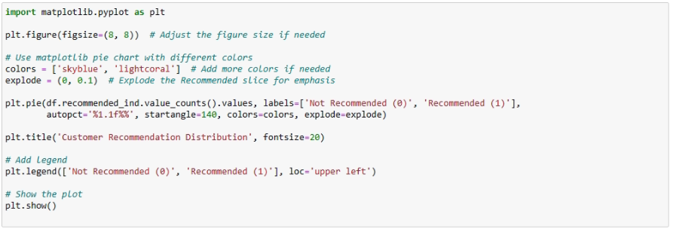

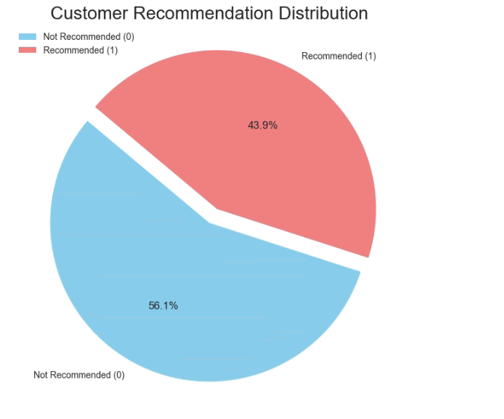

## 4.3 - The Examination of Other Feature

* The Examination of "rating" Variable

"rating" is a positive ordinal integer variable representing the product score assigned by the customer, ranging from 1 (worst) to 5 (best).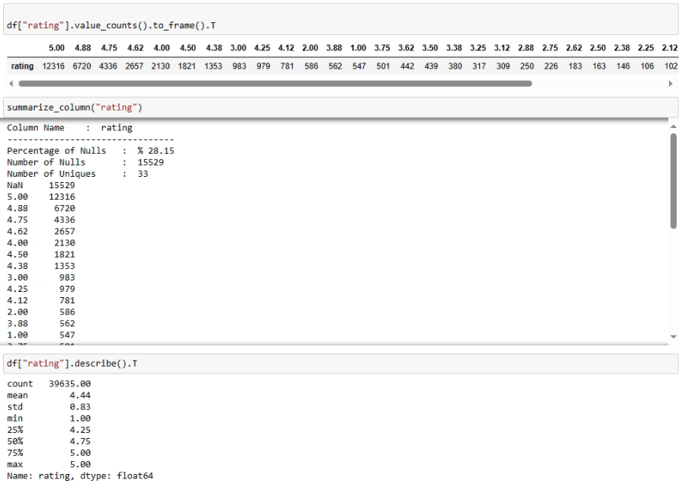

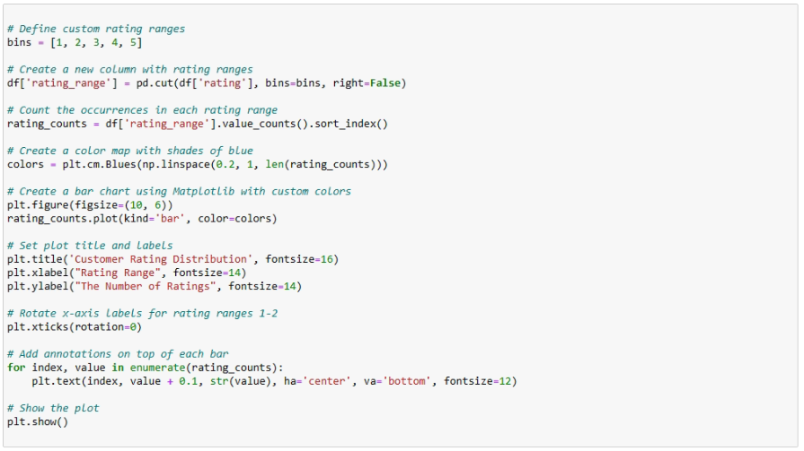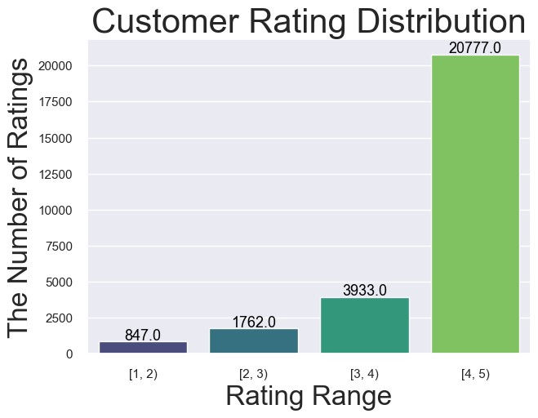

The distribution of customer ratings in the dataset indicates that a substantial majority, comprising 207,777 reviews, falls within the higher range of 4 to 5. This suggests a prevalent trend of positive feedback for the vehicles. Additionally, there are 3,933 reviews in the range of 3 to 4, 1,762 in the range of 2 to 3, and 847 in the lowest range of 1 to 2.

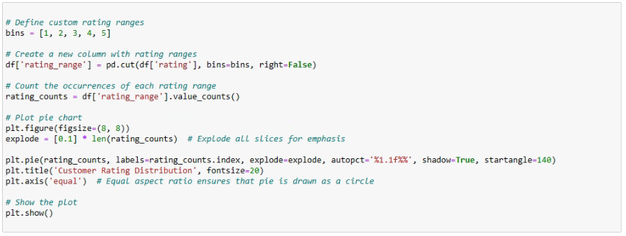

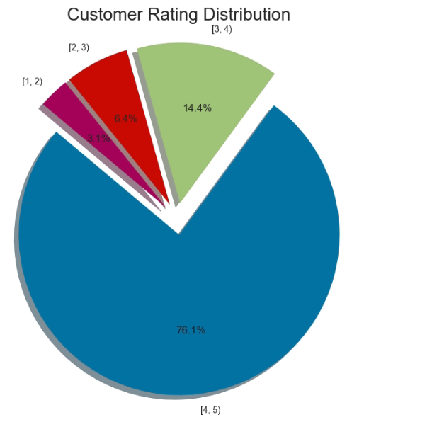

The Examination of "age" Variable

"age" is a Positive Integer variable of the reviewer’s age.

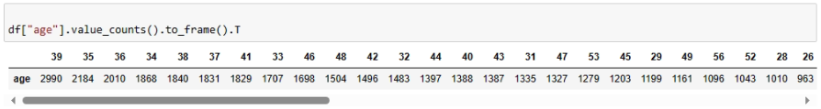

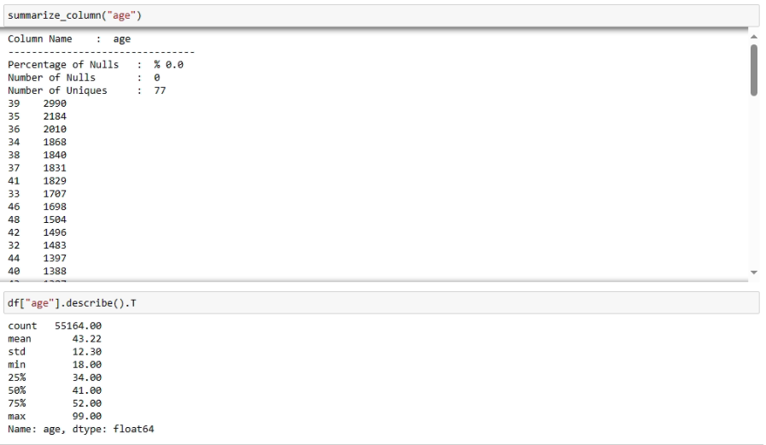

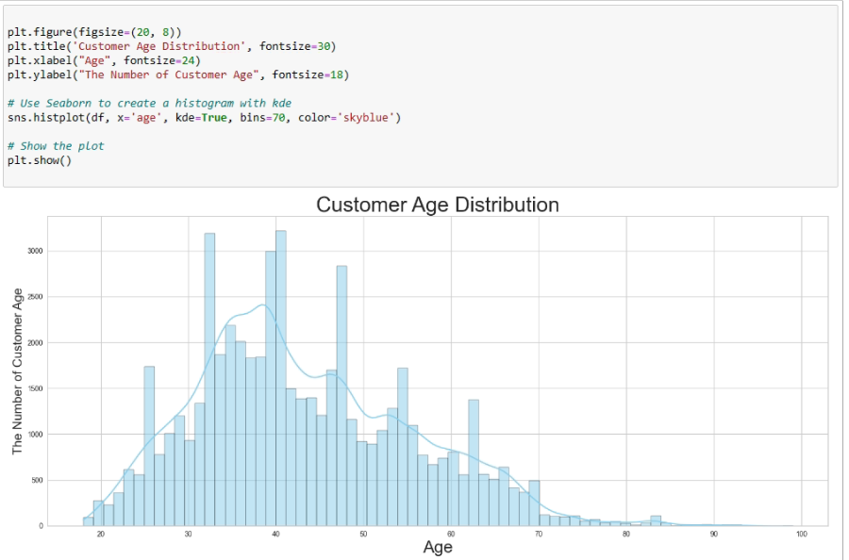

Here are some insights I can gather from the data:

Most Common Ages: The ages with the highest counts are 39, 35, 36, 34, and 38. These are the most common ages in the dataset.

Age Distribution: The data seems to have a relatively diverse distribution of ages, with a peak around the late 30s.

Decreasing Count with Age: As I move towards higher ages, the count tends to decrease, which is expected as the population generally decreases in older age groups.

Outliers: There is a notable drop in counts for ages beyond 70, indicating that there are fewer instances of individuals in those age groups in the dataset.

Sparse Age Groups: Some age groups, especially those in the late teens and early twenties, have lower counts, suggesting that the dataset might not be as representative for these age groups.

Age Group Variety: The dataset includes a variety of age groups, covering a broad range from 18 to 99.

* **The Examination of "vehicle_make" Variable.**

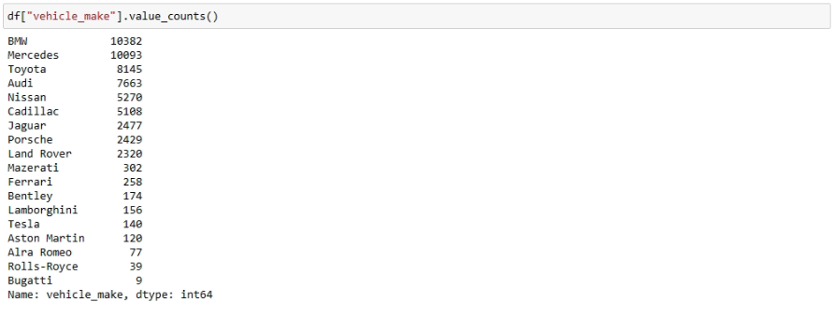

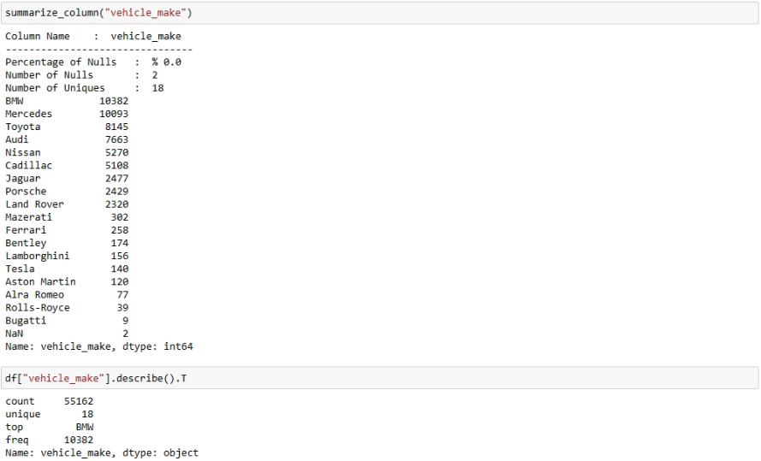

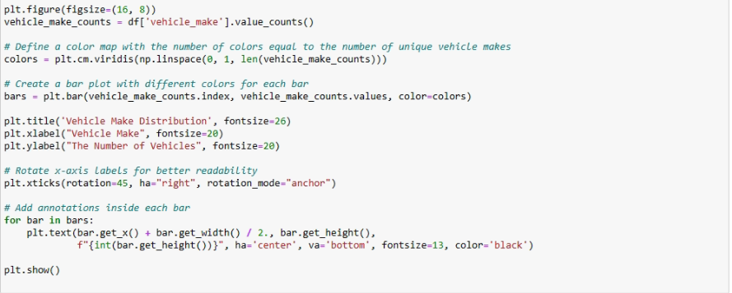

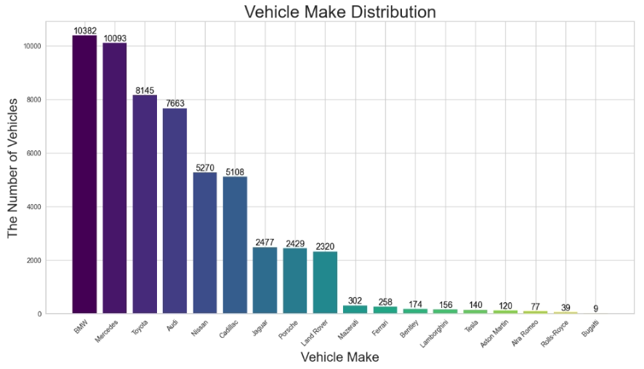

The two largest counts for vehicle make in the dataset are BMW with 10,382 reviews and Mercedes with 10,093 reviews. These high counts suggest that BMW and Mercedes are popular choices among consumers, resulting in a significant number of reviews. On the other hand, the two lowest counts belong to Bugatti with only 9 reviews and Rolls-Royce with 39 reviews. The low review counts for Bugatti and Rolls-Royce may be attributed to the exclusivity and limited market presence of these luxury brands.

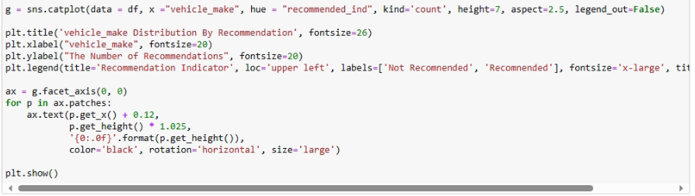

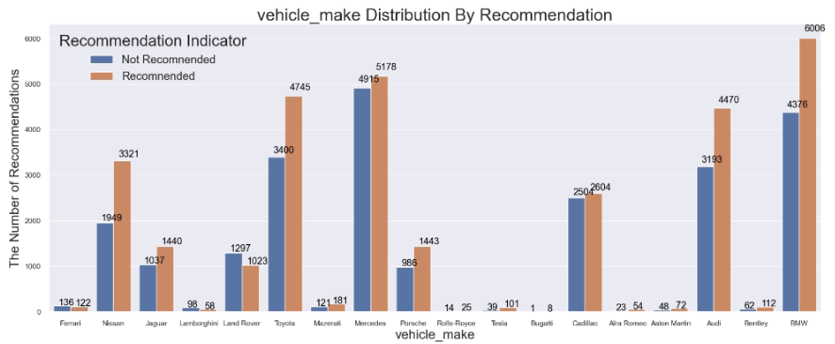

**Here are some observations:

**BMW (6006 rec, 4376 not):

BMW has a higher count of recommendations (6006) compared to non-recommendations (4376), indicating a positive trend. Mercedes (5178 rec, 4915 not):

Mercedes has a higher count of recommendations (5178), but the margin is narrower compared to BMW. The balance between recommendations and non-recommendations is relatively close. Toyota (4745 rec, 3400 not):

Toyota also shows a positive trend with a higher count of recommendations (4745) compared to non-recommendations (3400). Ferrari (122 rec, 136 not):

Ferrari has a lower count of recommendations (122) compared to non-recommendations (136), which may indicate a more critical audience or specific issues mentioned in the reviews. Lamborghini

creating categorical and numerical sets provides a structured approach to data analysis, enabling the use of specific tools and techniques tailored to each data type. This segregation enhances the efficiency and depth of the analysis, leading to more meaningful insights and informed decision-making.

* create categorical and numerical sets for the examination of crosstab information. 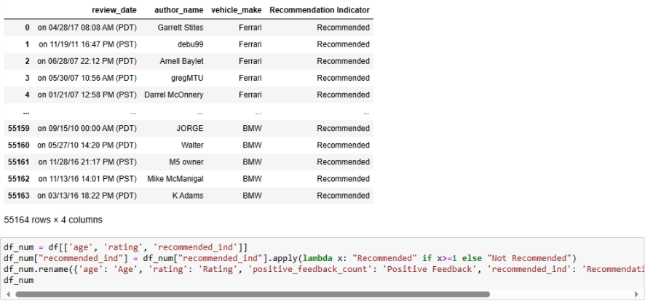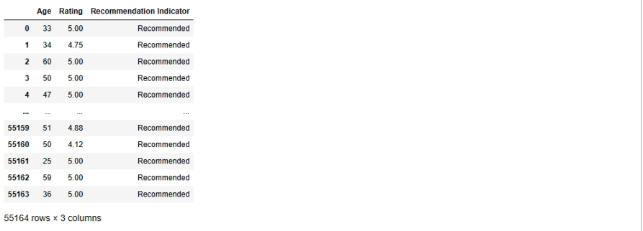
* generate and print cross-tabulations of categorical variables in a DataFrame

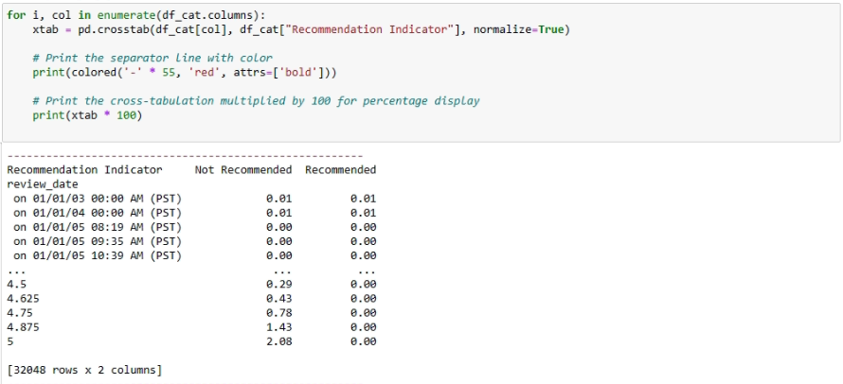

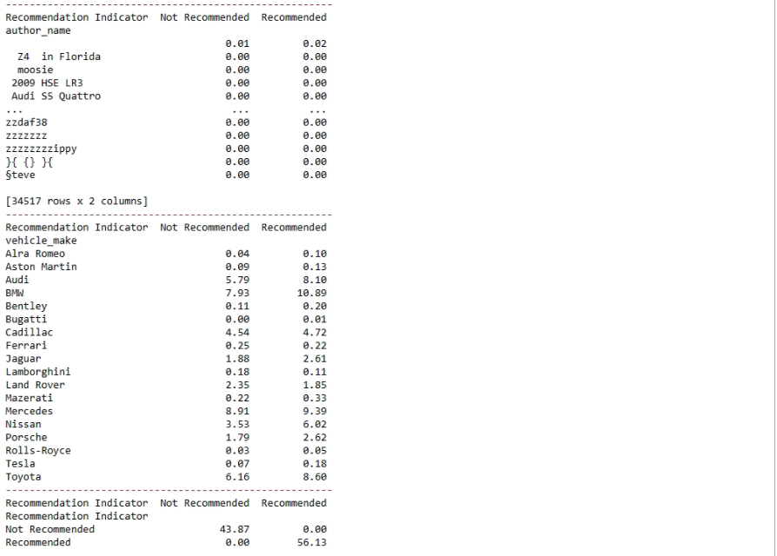

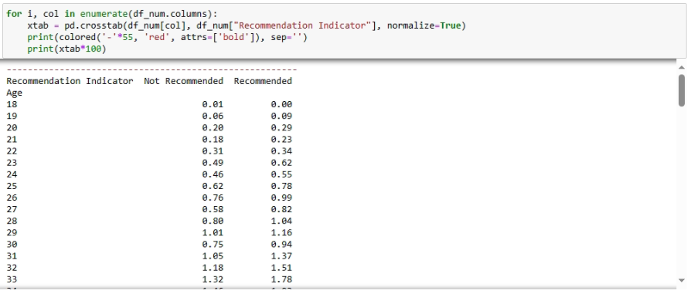

# 5) TEXT PREPROCESSING

* From now on, the DataFrame I will work with should contains two columns: "review " and "recommended_ind". I can do the missing value detection operations from now on.

## 5.1 Feature Selection



* For later parts of the analysis, I will drop unnecassary columns for NLP.keep only review and recommended_ind columns

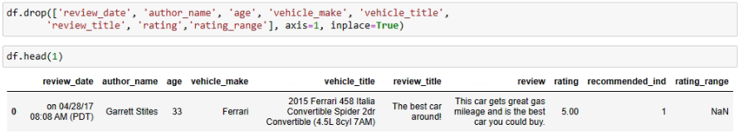

## 5.2 Dealing with Missing Values



* It looks like I have 12,783 missing values (NaNs) in the 'review' column of my
* DataFrame. To handle these missing values, I can either drop the rows containing NaNs or fill them with a specific value, no missing values inrecommended_ind colum shown below.



* I will remove the rows where the 'review' column has NaN values.

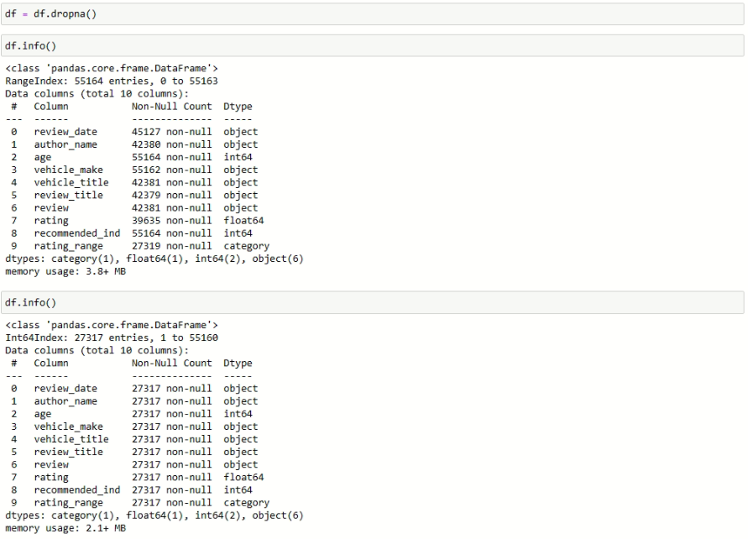

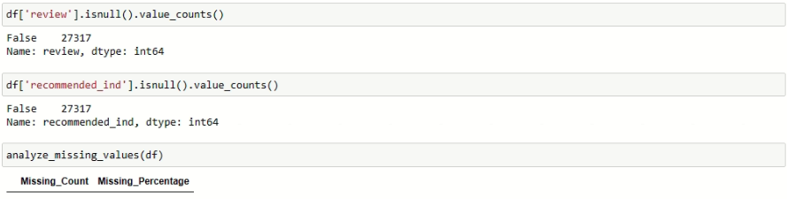

* Sometimes I cannot detect missing values if they consist of empty (blank) string such as " ". In this situation I can use the following syntax.

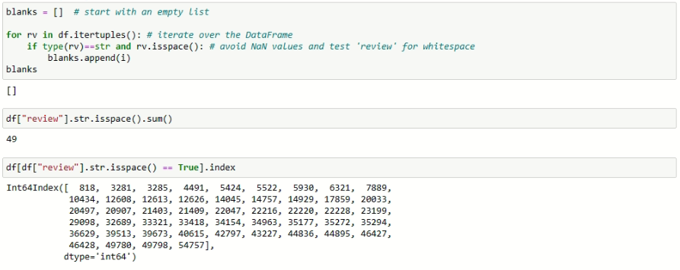

# 6) TEXT PREPROSSING

Text, being highly unstructured, contains various forms of noise that hinder immediate analysis. Text preprocessing is the crucial procedure of cleaning and standardizing textual data to eliminate noise, making it suitable for analysis.

The text preprocessing process involves three key steps:

**Tokenization:** the process of breaking down a piece of text into individual words or tokens.

**Noise Removal:** Identifying and eliminating irrelevant text elements, including language stopwords, URLs, case variations, punctuation, and industry-specific words.

**Lexicon Normalization:** Lexicon normalization involves transforming words to a common base or root, making variations of the same word comparable. The two common techniques for lexicon normalization are stemming and lemmatization.

The initial step involves converting text to tokens and lowercasing all words. Subsequently, punctuation, special characters, numbers, and stop words are removed. The second step focuses on normalizing the text through the Lemmatization method.

## 6.1 Tokenization

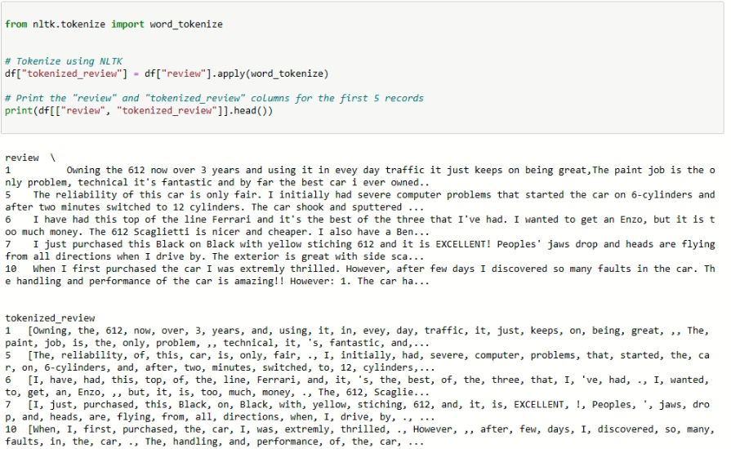

## 6.2 Noise Removal

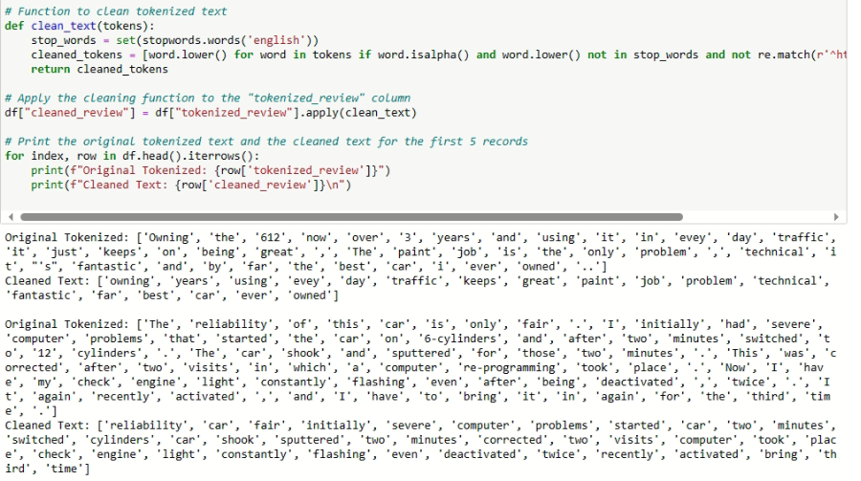

## 6.3 Stemming

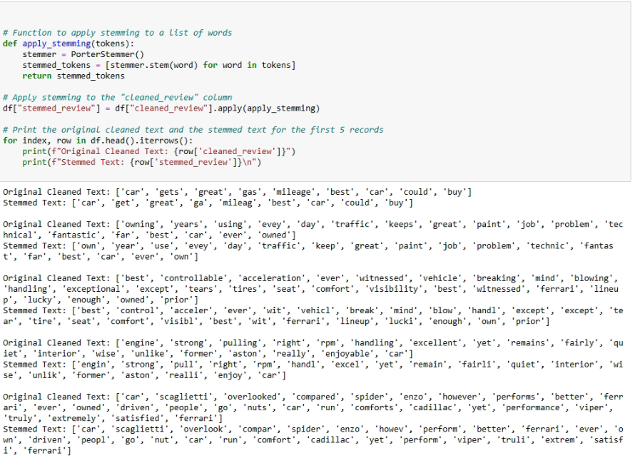

## 6.4 Lemmatization

* perform lemmatization on the "cleaned_review" column in DataFrame, I can use spaCy,

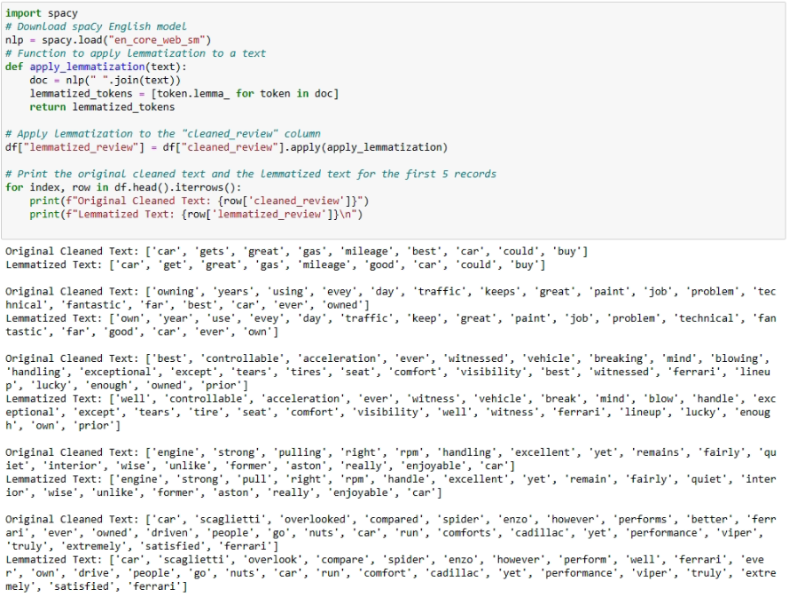

* Lemmatization, is a more sophisticated process that involves reducing words to their base or dictionary form (lemma) While The goal of stemming is to reduce words to their base or root form by removing suffixes or prefixes.
* creates a new column named "review" and copies the content of the "lemmatized_review" column to it. I can then use the "review" column for my text representation task

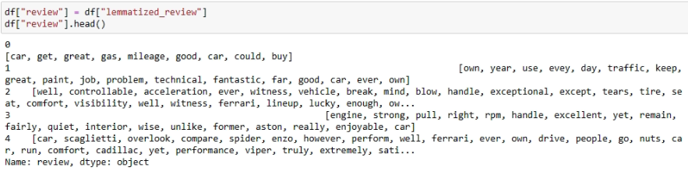

## 6.5 Handling Rare Words

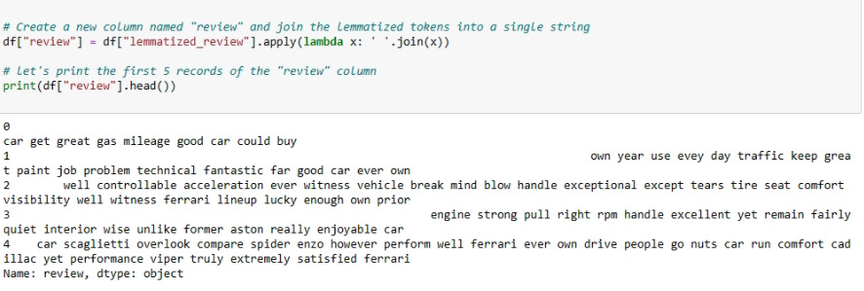

* Calculate and display the word frequencies.

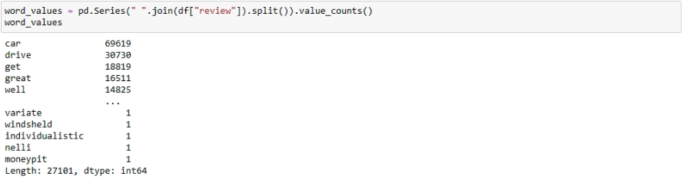

* filters out words with frequencies less than or equal to 2 the calculate the total number using rare_words.value_counts**()**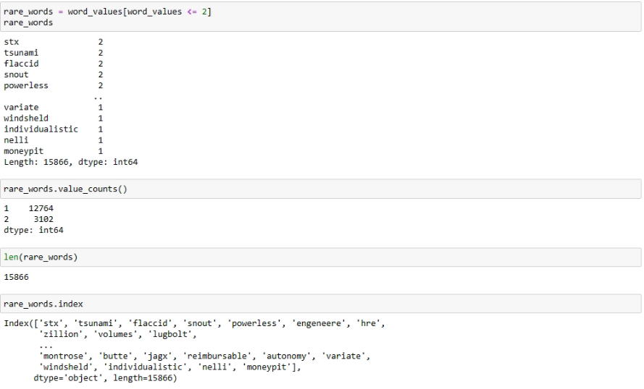
* remove words with frequencies less than or equal to 2 from the "review" column in DataFrame

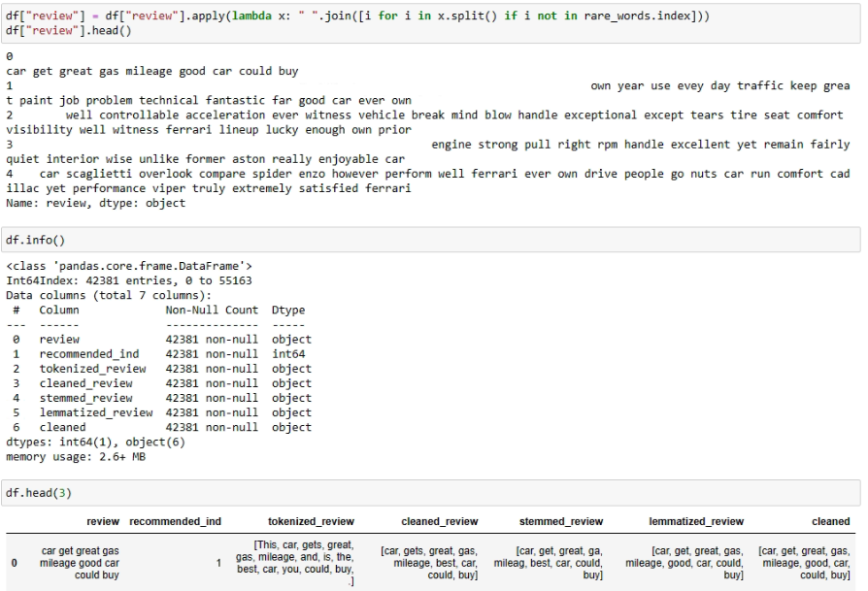

* After Text Preprocessing I can notice the following
* review: Original text or the input text column
* recommended_ind: Possibly a column indicating whether a recommendation is present or not (binary recommendation indicator). tokenized_review: Column containing tokenized versions of the text.
* cleaned_review: Column containing text after cleaning (removing stopwords, converting to lowercase, etc.). stemmed_review: Column containing text after stemming. lemmatized_review: Column containing text after lemmatization.
* cleaned: The column I mentioned earlier, which I indicated want to use for text

# 7) TEXT REPRESENTATION

Creating word clouds for positive and negative reviews can provide insightful visualizations. this task can be done as follows:

**Detect Reviews:** Filter Data: Separate the dataset into positive and negative reviews based on the recommended status.

**Collect Words:** 1-Text Preprocessing: Apply text preprocessing techniques (tokenization, lowercasing, removal of stopwords, etc.) to clean the review text. 2-Word Frequency: Count the frequency of each word in positive and negative reviews separately.

**Create Word Cloud:** 1-Generate Word Clouds: Utilize a word cloud library (e.g., wordcloud in Python) to generate word clouds for positive and negative reviews. 2-Visualization: Visualize the word clouds, where words are displayed with sizes proportional to their frequencies.

## 7.1 The Detection of Positive and Negative Reviews

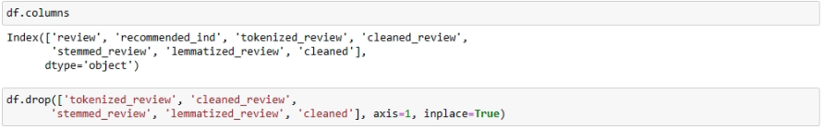

* creates a new DataFrame (filtered_df) containing only the rows where the value in the "recommended_ind" column is equal to 1

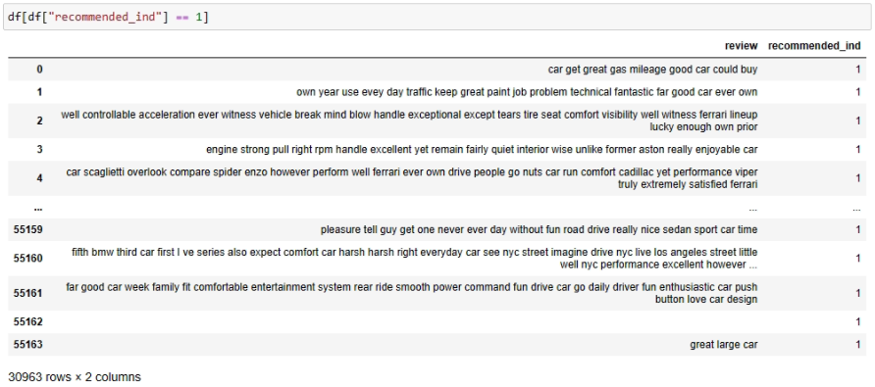

* creates a new DataFrame (filtered_df) containing only the rows where the value in the"recommended_ind" column is equal to 0

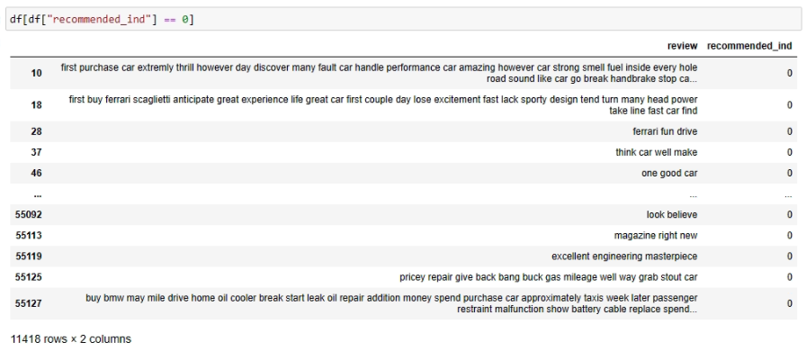

## 7.2 The Collection of Positive and Negative Words

* Collect Words (positive and negative separately)

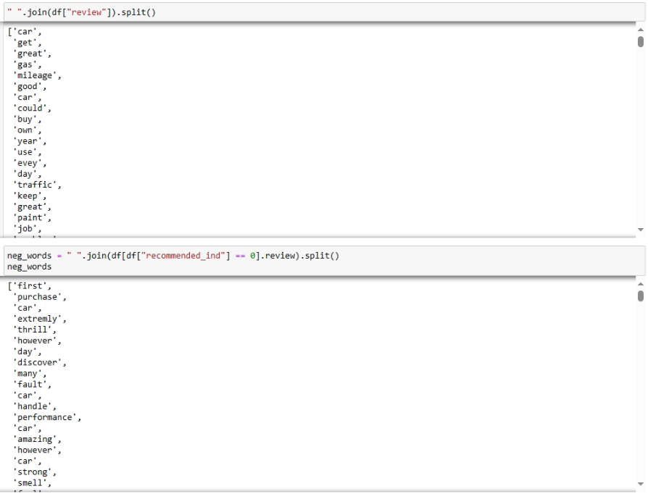

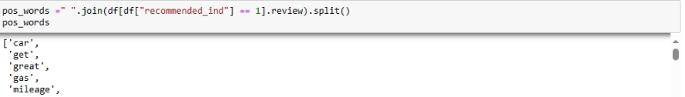

## 7.3 Creating of Word Cloud

* Let's create Word Cloud for most common words in recommended not recommended reviews separately.

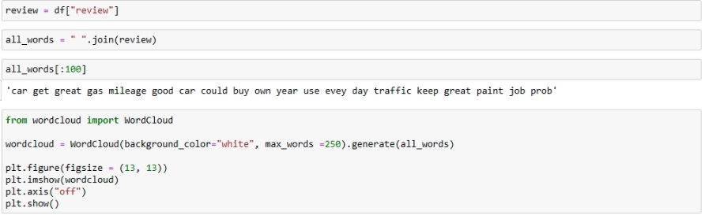

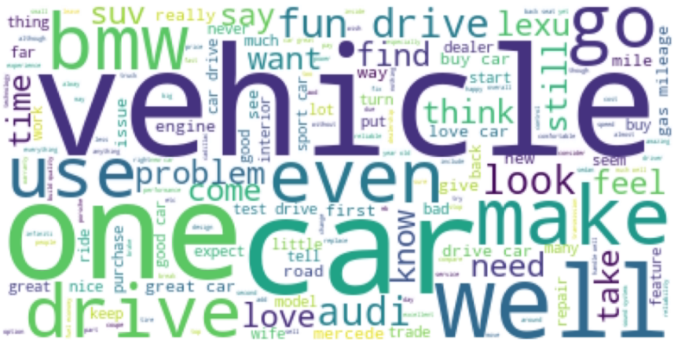

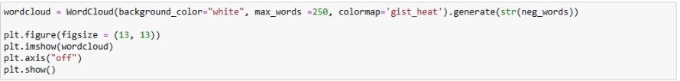

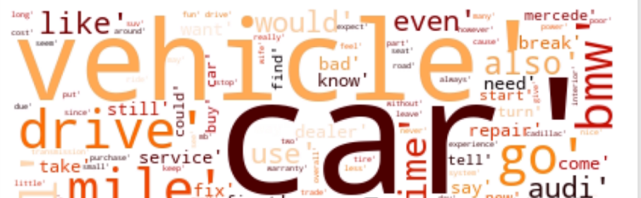

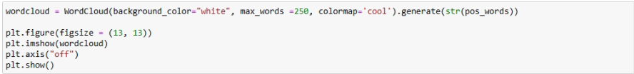

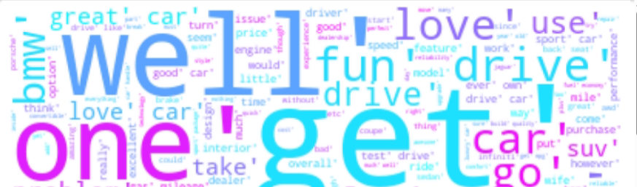

## 7.4 Part Of Speech Tagging

* implement part-of-speech tagging in the review column, useing the Natural Language Toolkit (nltk) library in Python.

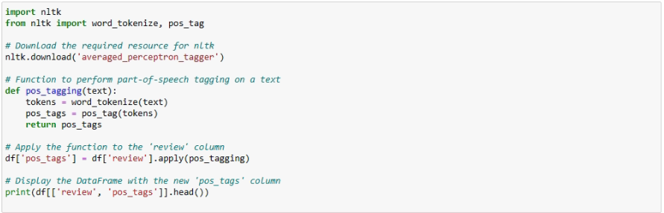

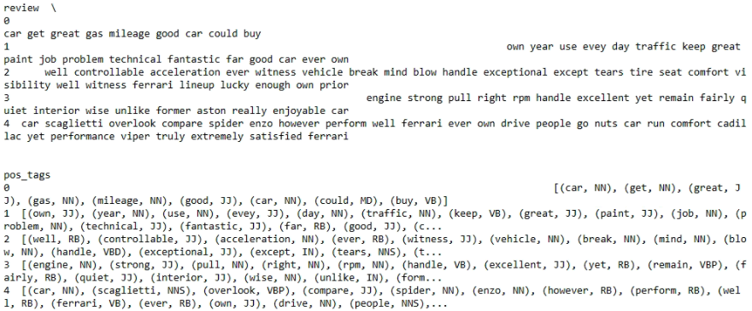

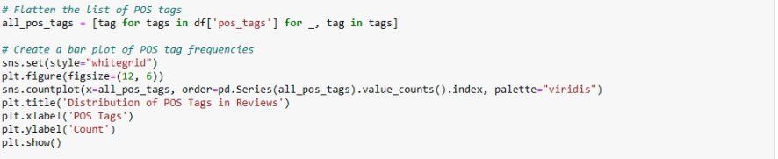

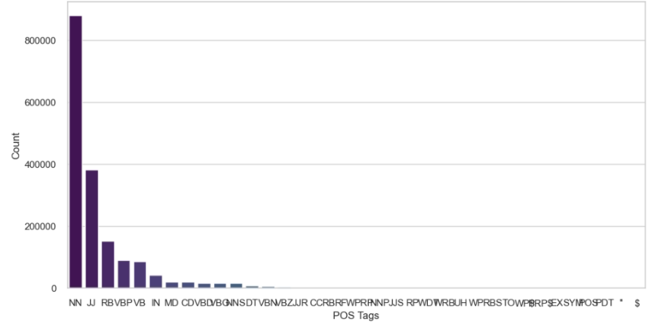

* the bar plot showing the distribution of different POS tags,This suggests that nouns are commonly used in the reviews, followed by adjectives and adverbs. The distribution of POS tags provides insights into the linguistic characteristics of the reviews, indicating the types of words that are more prevalent in the dataset.

## 7.5 Named Entity Recognition

* implement NER in the review column, useing the spaCy library in Python.

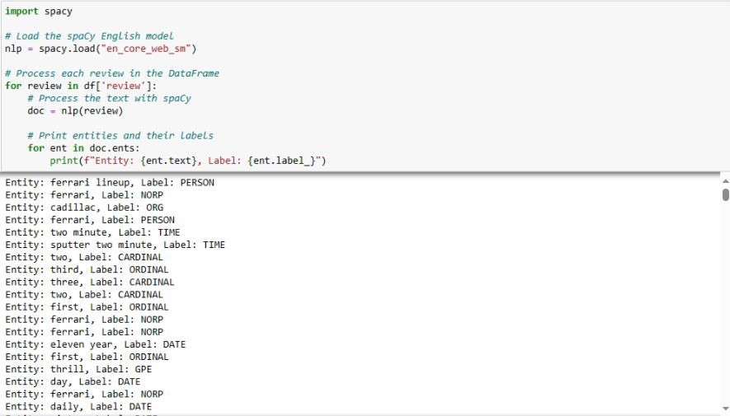

## 7.6 Word Embeddings

* perform word embeddings for the review column, by using pre-trained word embeddings models such as Word2Vec ,the example below shows the work embedding for word Nissan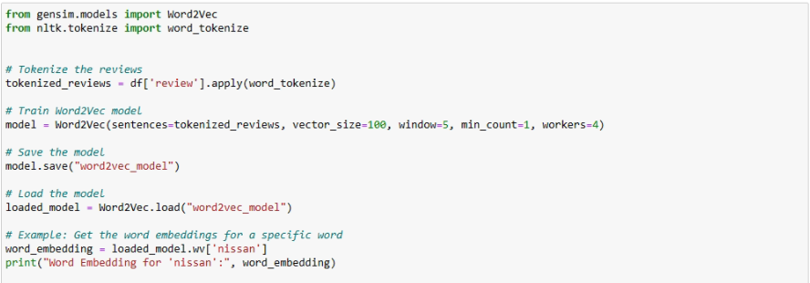

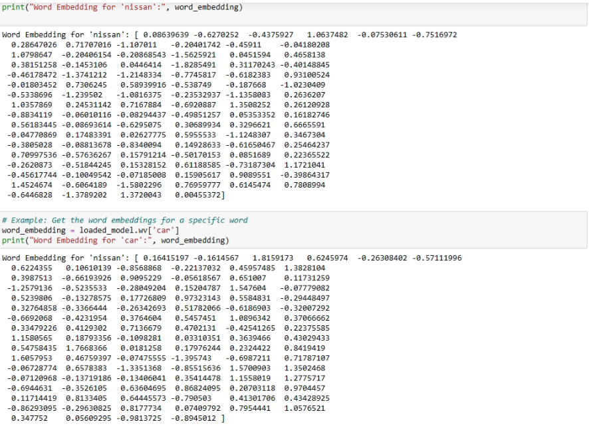

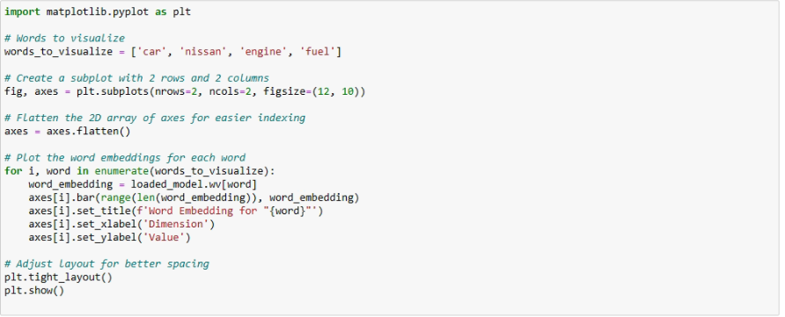

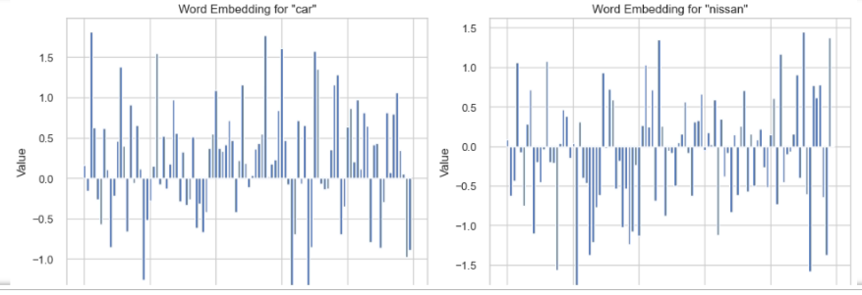

## 7.7 Bag of Words

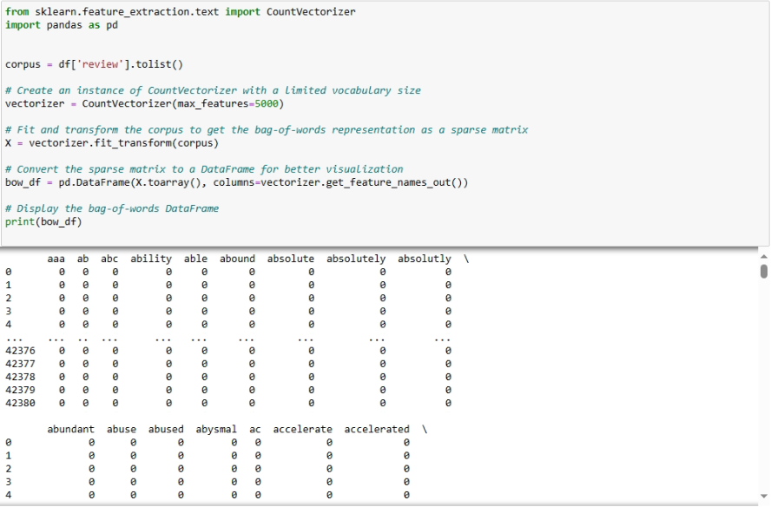

# 8) SENTIMENT CLASSIFICATION WITH MACHINE LEARNING & DEEP LEARNING

Before delving into the modeling phase, it's essential to undertake data preprocessing steps. One crucial aspect involves vectorization and the initial implementation of it will occur at this stage.

Machine learning algorithms commonly expect numeric feature vectors as input. Consequently, when dealing with text documents, a mechanism is required to convert each document into a numeric vector. This process is termed text vectorization. For my specific case, I will employ a widely used vectorization approach: representing each text as a vector of word counts.

At this juncture, my review text column is in token form, devoid of punctuation and stopwords. To convert the text collection into a matrix of token counts, I can leverage Scikit-learn's CountVectorizer. This resulting matrix can be envisioned as a 2-D matrix where each row corresponds to a unique word, and each column corresponds to a review.

For the deep learning model, I will incorporate an embedding layer for all words.

Following the completion of data preprocessing, I will proceed to construct models utilizing the following classification algorithms:

* **Naive Bayes :**

it is computationally efficient and simple to implement. Particularly effective for text classification tasks, such as spam filtering or sentiment analysis.also it performs well in situations where the number of features is high compared to the number of samples.

* **Support Vector Machine**

SVM works well in high-dimensional feature spaces, making it suitable for a variety of applications.SVM often performs well in practice, especially when the data is not too large.

* **Deep Learning Model**

Deep learning models automatically learn hierarchical representations from the data, potentially capturing complex patterns. can benefit from large amounts of labeled data

## 8.1 Train | Test & Split

* To run machine learning algorithms, I need to convert text files into numerical feature vectors. I will use bag of words model for my analysis.
* Let's first I split the data into train and test sets:

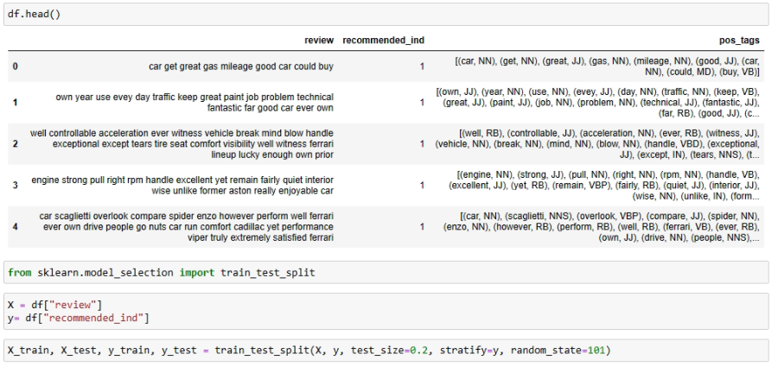

* In the next step, i will create a numerical feature vector for each document:

## 8.2 Vectorization

Vectorization is a process of converting textual data into a numerical format that can be used as input for machine learning models Count Vectorization and TF-IDF (Term Frequency-Inverse Document Frequency) Vectorization are two popular techniques for converting text data into numerical representations suitable for machine learning models.

i will use Count Vectorization for the following reasons,

1- Simple and computationally efficient.

2-Suitable for tasks where the emphasis is on the frequency of terms within documents.

3- Good for tasks like spam detection, sentiment analysis, and topic modeling.

then i will implement TF-IDF Vectorization because:

1-Effective in capturing the importance of terms across the entire corpus.

2-Suitable for tasks where distinguishing terms based on their uniqueness is important.

3 Commonly used in information retrieval text classification and document clustering tasks

**8.2.a Count Vectorization**

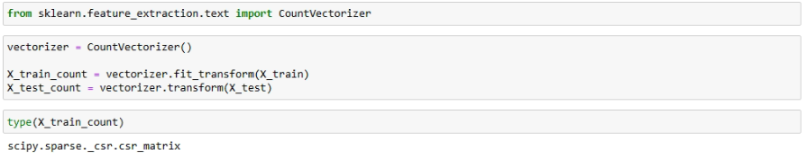

* **X**_train_count_array will be a dense NumPy array representing the document-term matrix where each row corresponds to a document, and each column corresponds to a unique word, with the values representing the count of each word in each document.

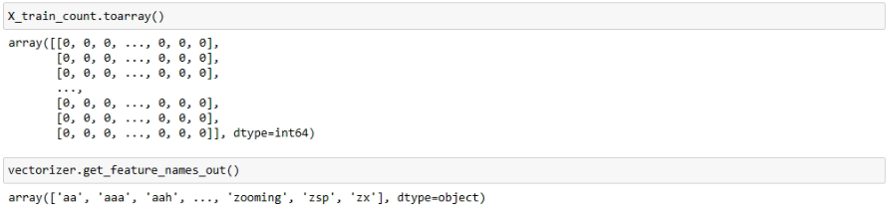

* creating a Pandas DataFrame from the dense NumPy array obtained from the toarray(),The resulting df_train_count DataFrame will have rows corresponding to different text samples and columns corresponding to the unique words in the training data, with the values representing the word counts for each sample.

### 

**8.2.b TF-IDF Vectorization**

Represents each document as a vector where each component corresponds to the TF-IDF weight of a term. The resulting matrix has rows corresponding to documents and columns corresponding to unique terms in the entire corpus.

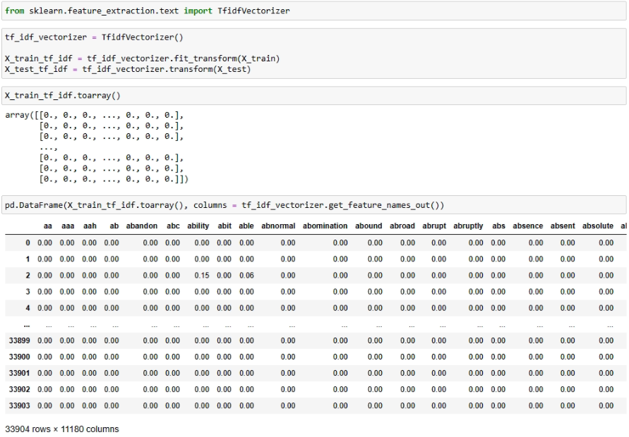

[197]:

* Before diving into modelling, I will create a User-Defined-Function for comparing models at the end. 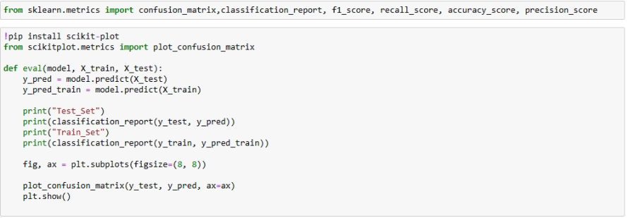
* Now it's time to train all models using TFIDF and Count vectorizer data.

# 9) MACHINE LEARNING MODELLING

## 9.1 Naive Bayes

I want to make comparison between Naive Bayes with Count Vectorizer and TF-IDF (Term Frequency-Inverse Document Frequency) by evaluating their performance in the context of current dataset.

### 9.1.a Naive Bayes with Count Vectorizer

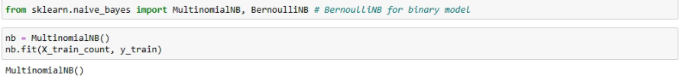

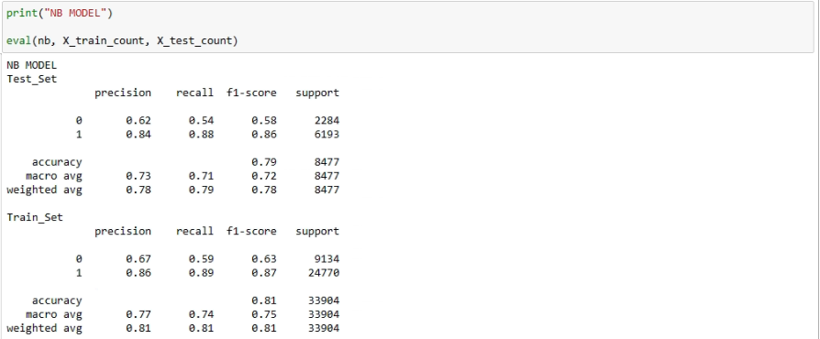

**Interpretation:**

* The model performs well in identifying instances labeled as "Recommended," showing high precision and recall.
* There's room for improvement in correctly identifying instances labeled as "Not Recommended" (class 0).
* The overall accuracy is decent, but considering both precision and recall is essential, especially in cases of class imbalance.

while the model demonstrates good performance, further optimization, especially for class 0, could enhance its predictive capabilities.

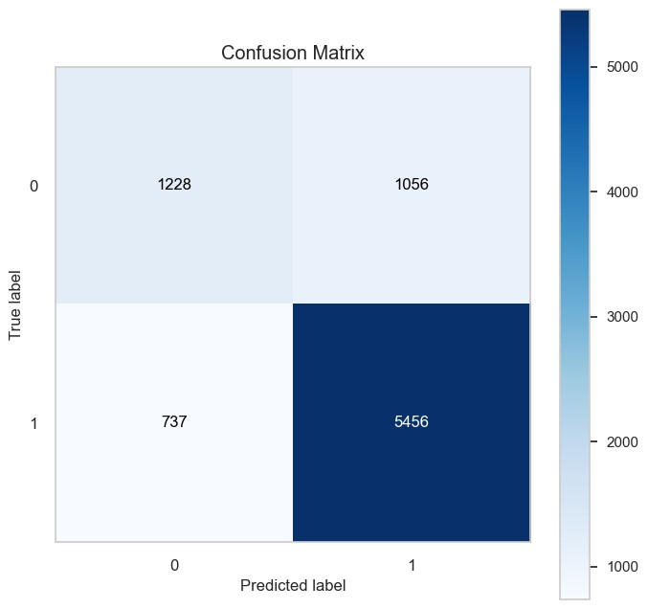

* **how to read a confusion matrix**

After completing the model training, I proceeded to generate predictions for a set of 8477 reviews within the validation dataset. For these predictions, I have access to the true labels, enabling us to assess the model's predictive performance.

• True Positive (TP):

This corresponds to the bottom-right (dark blue) corner of the evaluation matrix. It represents the instances where the model correctly identified positive cases. In the context of review prediction, this translates to the accurate prediction of recommendations (1). In my specific example, the count of true positives stands at 5456.

• True Negative (TN):

Found in the top-left (sky blue) corner of the matrix, this indicates the number of correctly identified negative cases. These are instances where the actual label is negative, and the model accurately predicted it as negative. In review prediction, this aligns with correctly anticipated non-recommendations (0). For the given example, the true negatives total 1228.

• False Positive (FP):

Positioned in the top-right (light blue) corner of the matrix, this represents the count of incorrectly predicted positive cases. In simpler terms, these are instances where the actual label is negative, but the model erroneously predicted it as positive. Often referred to as false alarms or Type 1 errors, in review prediction, this denotes the number of predicted recommendations incorrectly labeled as (1). In my example, false positives amount to 1056.

• False Negative (FN):

Situated in the bottom-left (white) corner of the matrix, this signifies the instances of incorrectly predicted negative cases. Essentially, these are situations where the actual label is positive, but the model predicted it as negative. Described as missed cases or Type 2 errors, in review prediction, this corresponds to the number of recommendations that were overlooked.

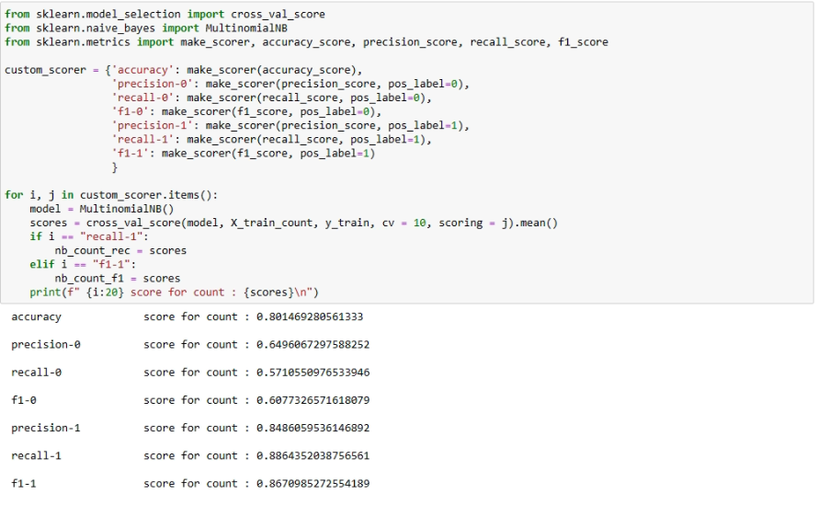

* The information obove includes various evaluation metrics for a Naive Bayes model used to predict customer recommendations. Let's break down each metric and discuss how to analyze the information:

1. Accuracy: Accuracy Score: 0.8015

This metric represents the overall correctness of the predictions, indicating the ratio of correctly predicted instances to the total instances. In my case, the model achieves an accuracy of approximately 80.15%.

1. Precision, Recall, and F1-Score for Class 0 (Non-recommendation):

Precision-0: 0.6496

Recall-0: 0.5711

F1-0: 0.6077

These metrics focus on the performance of the model concerning instances labeled as non-recommendation (Class 0).

Precision-0: The proportion of correctly predicted non-recommendations among all instances predicted as non-recommendation.

Recall-0: The proportion of correctly predicted non-recommendations among all actual non-recommendations.

F1-0: The harmonic mean of precision-0 and recall-0, providing a balanced measure.

1. Precision, Recall, and F1-Score for Class 1 (Recommendation):

Precision-1: 0.8486

Recall-1: 0.8864

F1-1: 0.8671

These metrics focus on the performance of the model concerning instances labeled as recommendation (Class 1).

Precision-1: The proportion of correctly predicted recommendations among all instances predicted as recommendation.

Recall-1: The proportion of correctly predicted recommendations among all actual recommendations.

F1-1: The harmonic mean of precision-1 and recall-1, providing a balanced measure.

1. Analysis:

* Overall Model Performance:

The accuracy of 80.15% suggests that the model performs reasonably well in making correct predictions across both classes.

Class 0 (Non-recommendation) Analysis: The lower precision (0.6496) and recall (0.5711) for Class 0 indicate that the model may have challenges correctly identifying instances of non-recommendation. It has a relatively higher rate of false negatives. The F1-0 score (0.6077) considers the balance between precision and recall for Class 0.

Class 1 (Recommendation) Analysis: The higher precision (0.8486) and recall (0.8864) for Class 1 suggest that the model is effective in correctly identifying instances of recommendation. It has a relatively lower rate of false negatives. The F1-1 score (0.8671) considers the balance between precision and recall for Class 1.

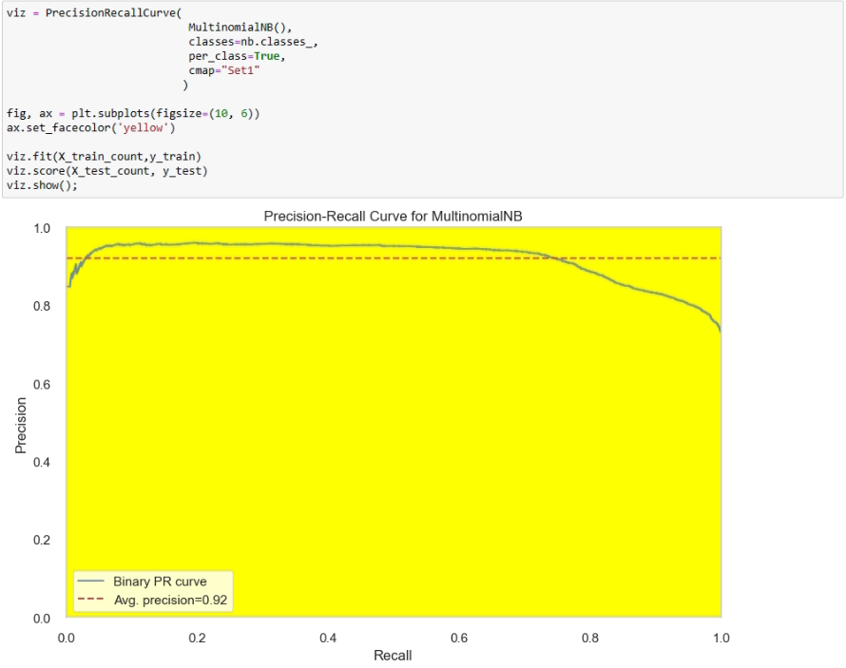

* In the evaluation of the model's Precision-Recall curve, it is observed that with an increase in the classification threshold from 8.8 to 9.4, there is a corresponding improvement in precision, indicating enhanced accuracy in positive predictions.
* Concurrently, recall also rises, affirming the model's capability to capture a greater number of positive instances with higher thresholds.
* The inherent trade-off between precision and recall underscores the strategic importance of selecting a threshold aligned with specific application objectives.
* Noteworthy is the identification of optimal operating points, particularly around thresholds of 9.3 to 9.4, where the model exhibits heightened precision, emphasizing its proficiency in accurately predicting positive instances. This nuanced analysis provides valuable insights for strategic decision-making in the deployment of the model for realworld applications



### 9.1.b Naive Bayes with TF-IDF Vectorizer



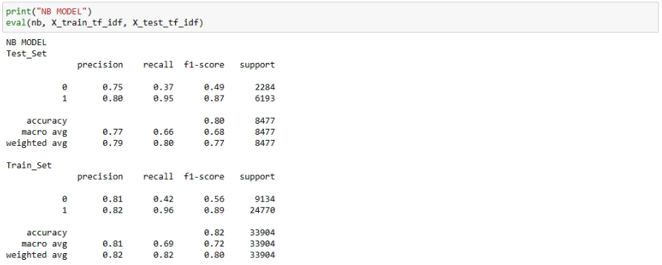

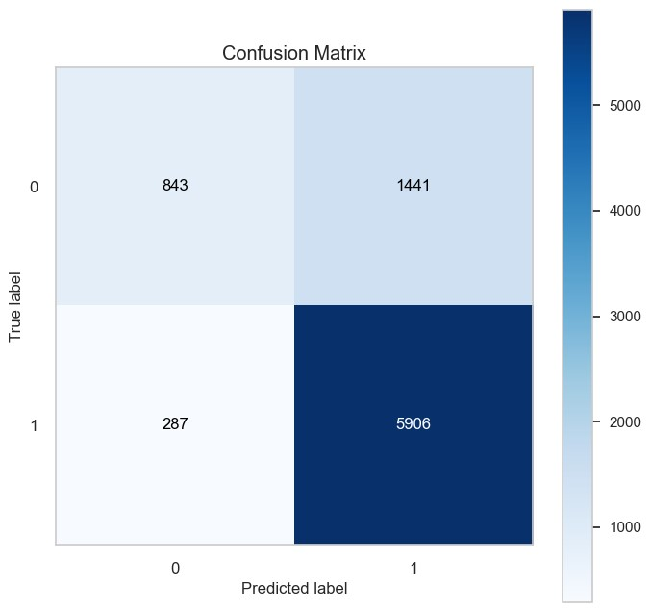

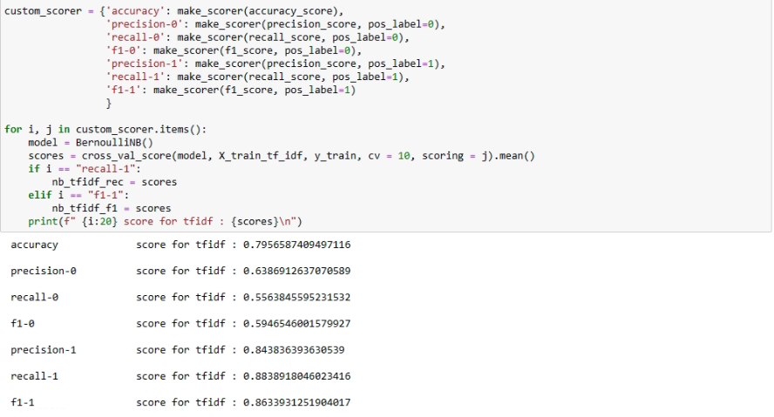

* Here is The comparison between Naive Bayes with Count Vectorizer and TF-IDF
  + The Naive Bayes model and Naive Bayes TF-IDF model show almost identical performance metrics.
  + Both models achieve high accuracy, precision, recall, and F1-scores, indicating their effectiveness in classifying instances.
  + The TF-IDF feature representation doesn't significantly impact the model's performance in this case.

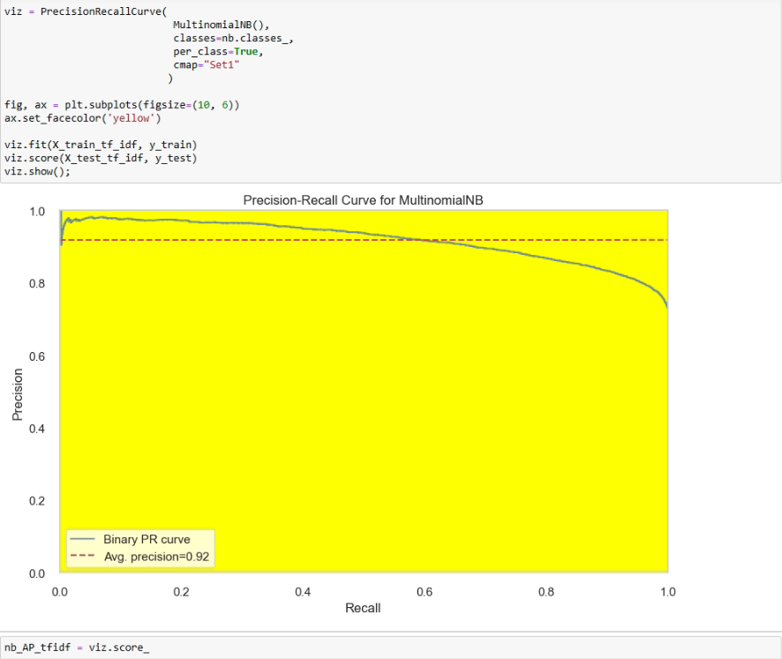

## 9.2 Support Vector Machine (SVM)

I want to make comparison between SVM with Count Vectorizer and TF-IDF (Term Frequency-Inverse Document Frequency) by evaluating their performance in the context of current dataset.

### 9.2.a Support Vector Machine (SVM) With Count Vectorizer



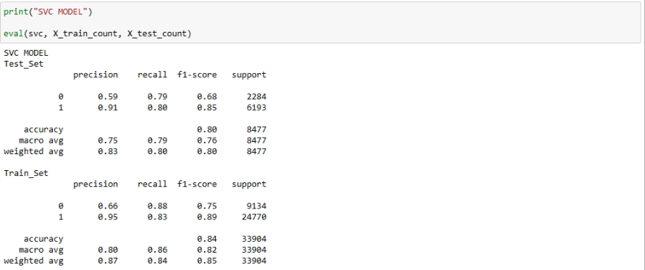

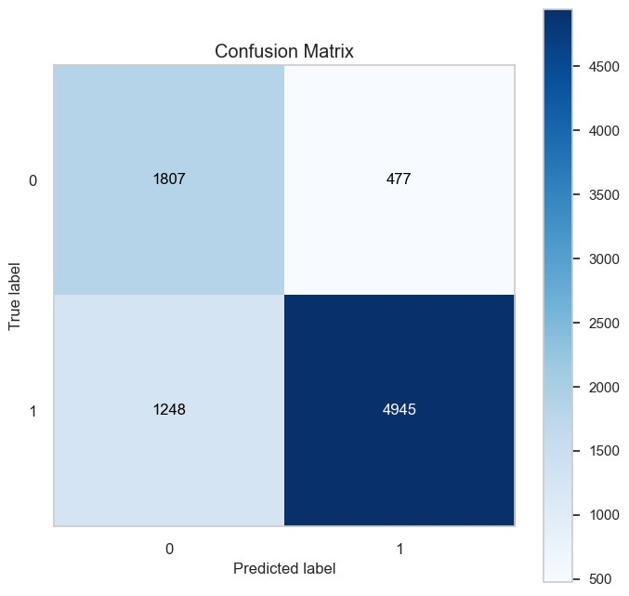

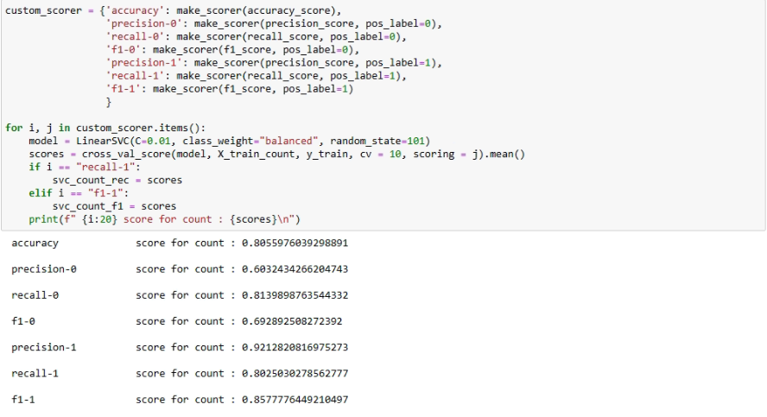

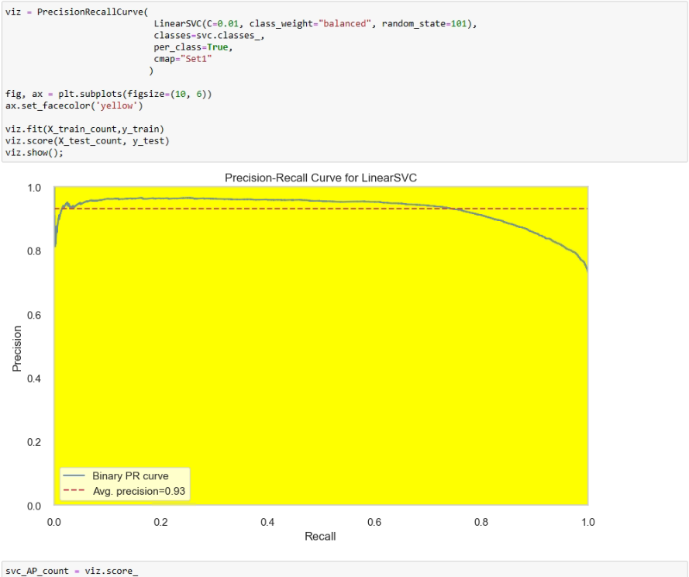

### 9.2.b Support Vector Machine (SVM) With TF-IDF Vectorizer



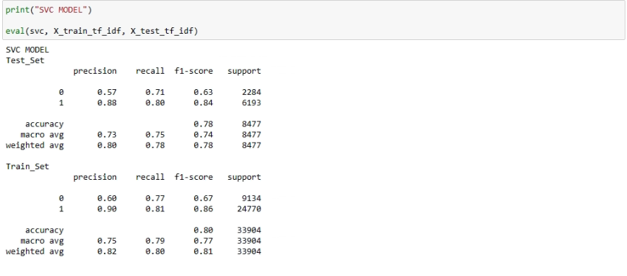

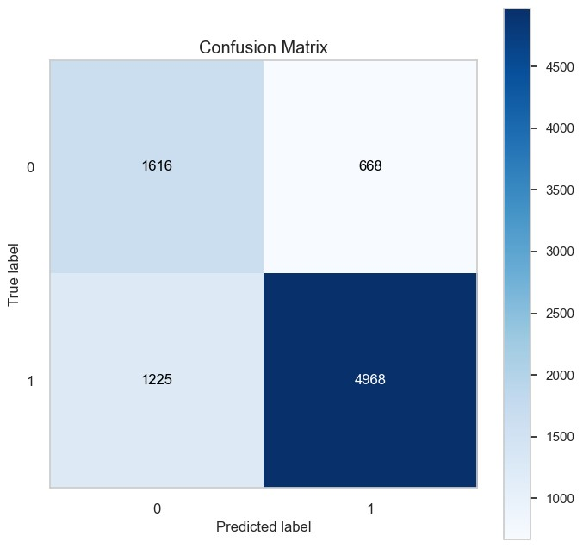

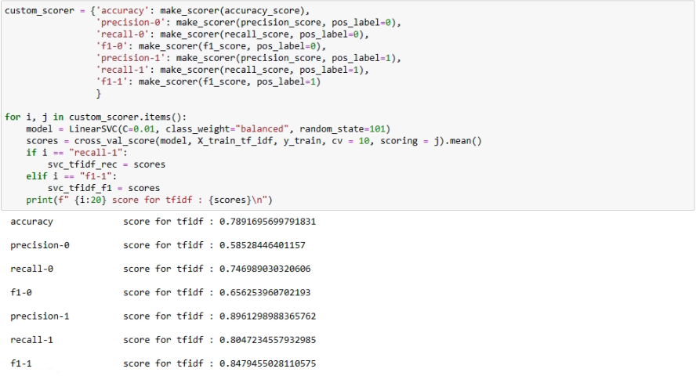

**• Here is The comparison between SVM with Count Vectorizer and TF-IDF**

* + The SVM model with the count vectorization scheme performs better overall compared to the SVM TF-IDF model.
  + The count-based SVM has higher accuracy, precision, recall, and F1-scores for both classes.
  + The TF-IDF representation has a slightly lower performance, especially in precision and F1-score for Class 0.

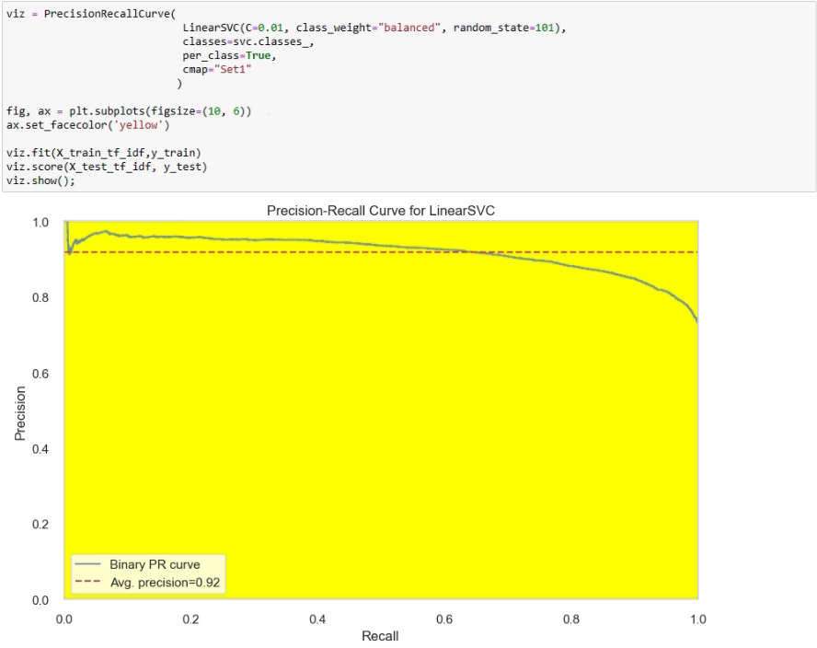

# 10) DEEP LEARNING MODELLING

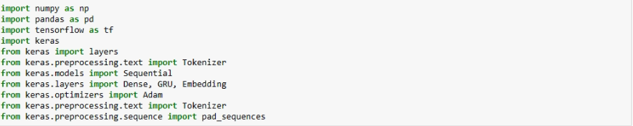

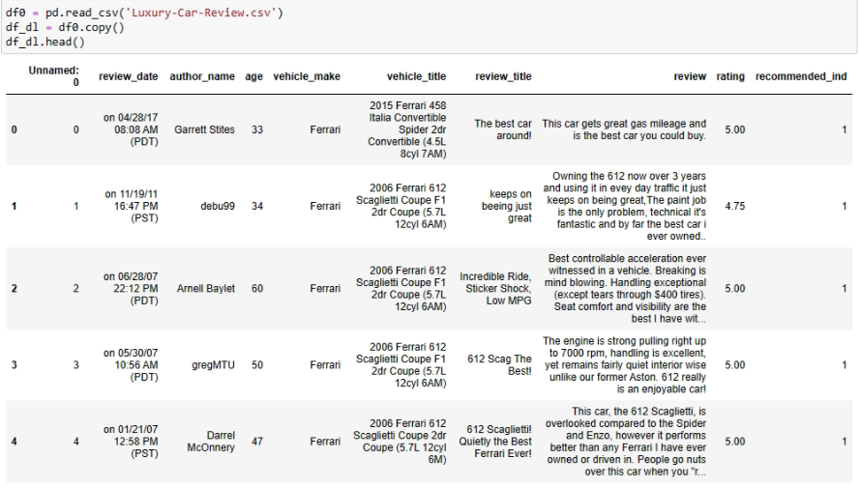

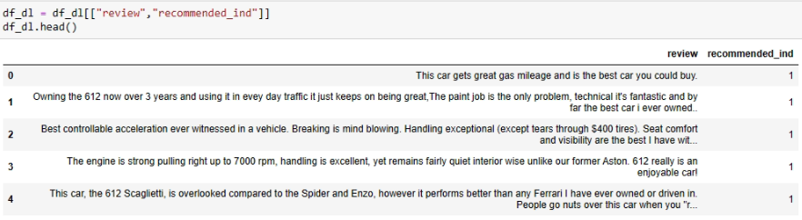

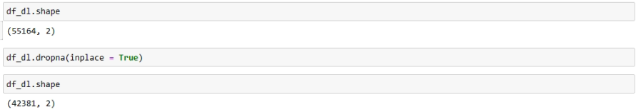

## 10.1 Tokenization

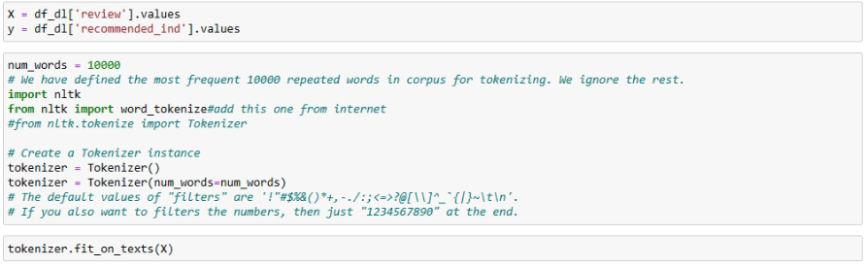

## 10.2 Creating Word Index

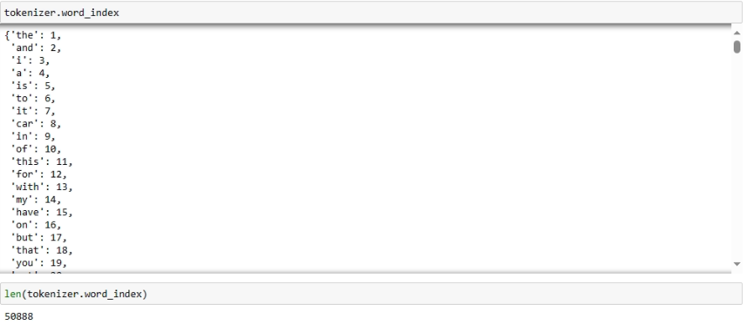

## 10.3 Converting Tokens To Numeric

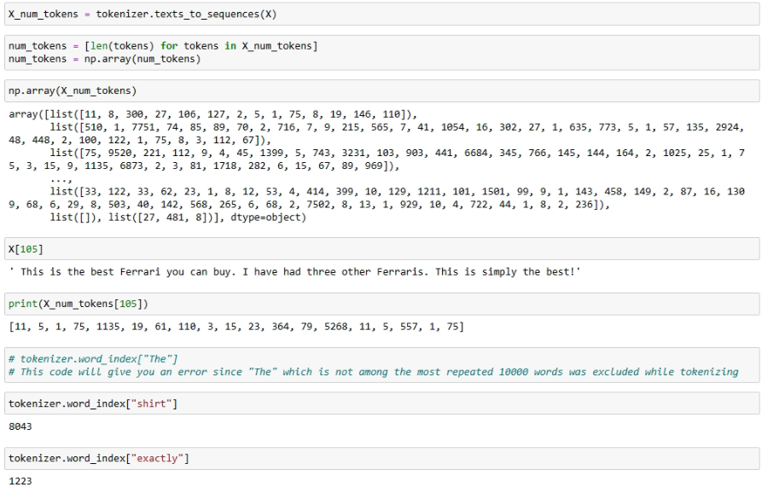

## 10.4 The Determination of Maximum Number of Tokens

* This part is the preparation for padding.

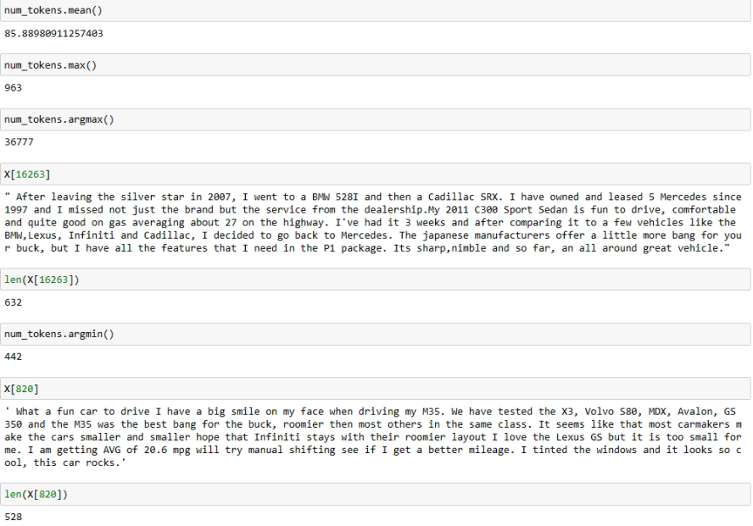

## 10.5 Fixing Token Counts of All documents (Pad Sequences)

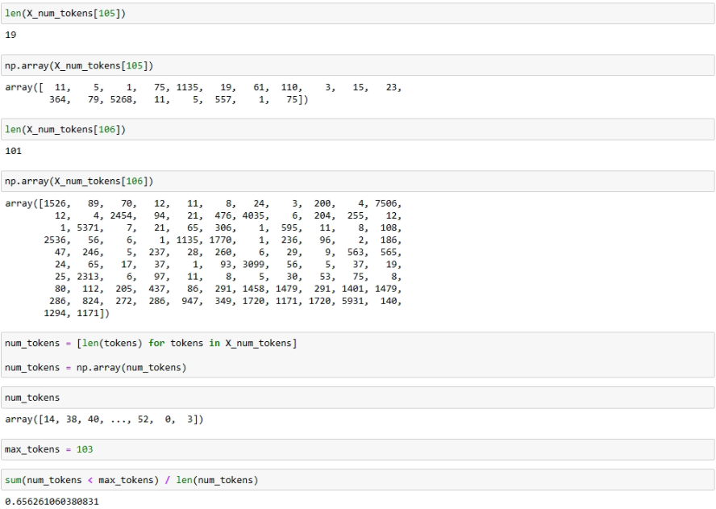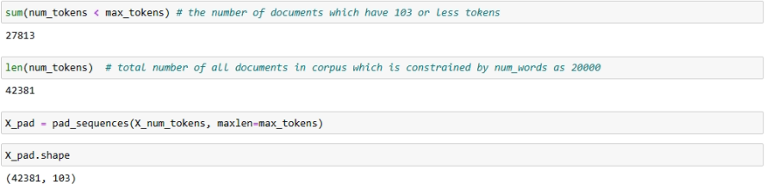

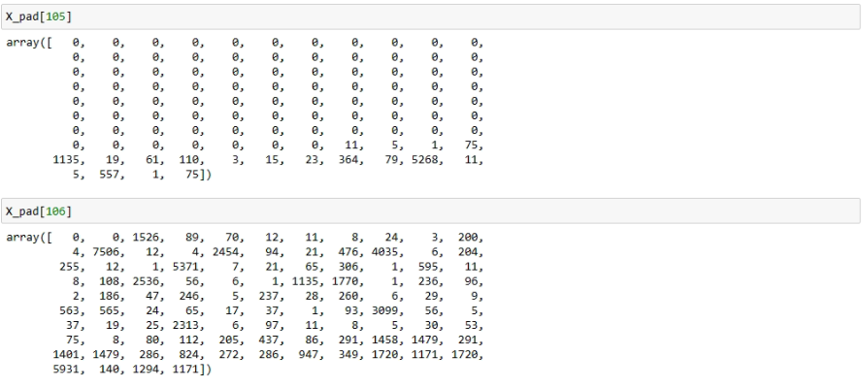

## 10.6 Train | Set & Split

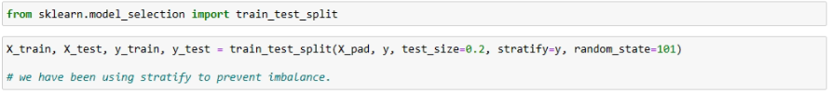

## 10.7 Modeling

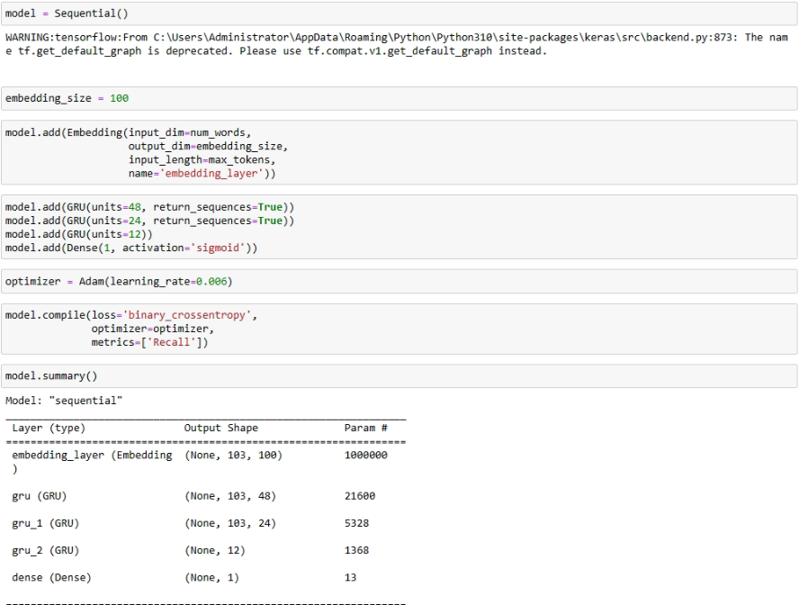

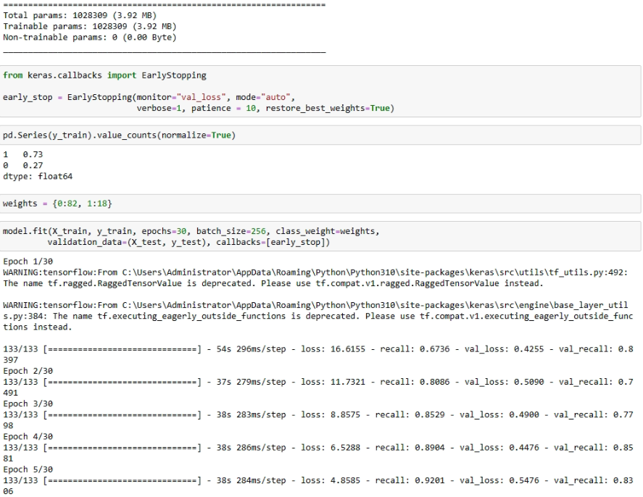

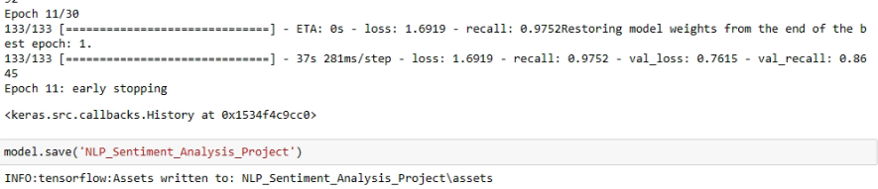

## 10.8 Model Evaluation

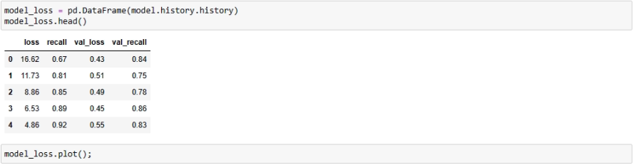

**Interpretation:**

1. **Training Progress:**
   * As training progresses (from epoch 0 to epoch 4), the loss decreases, indicating that the model is learning and improving its predictions.
2. **Recall Improvement:**
   * The recall on the training set increases from 0.67 to 0.92, suggesting that the model becomes better at identifying positive instances in the training data.
3. **Validation Performance:**
   * The validation loss initially decreases, but in later epochs, it starts to increase. This could indicate potential overfitting, where the model is too closely fitting the training data and not generalizing well to new data.
4. **Validation Recall:**
   * The validation recall fluctuates but generally remains high, indicating that the model maintains good performance on capturing relevant instances in the validation dataset.

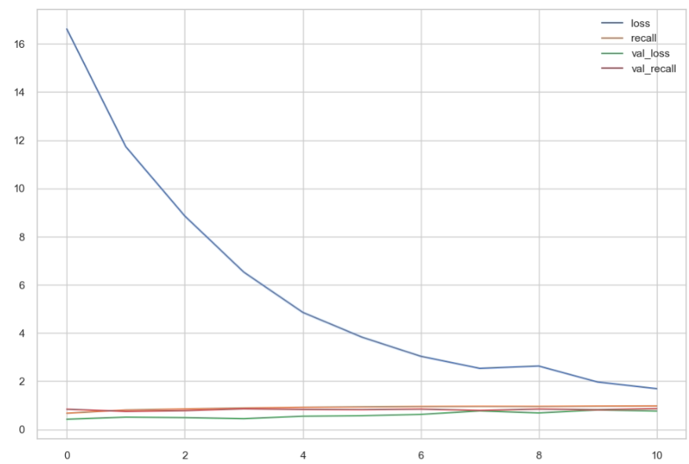

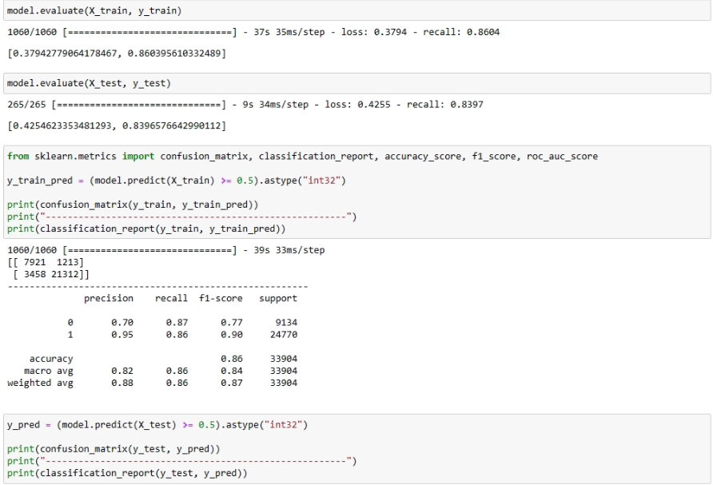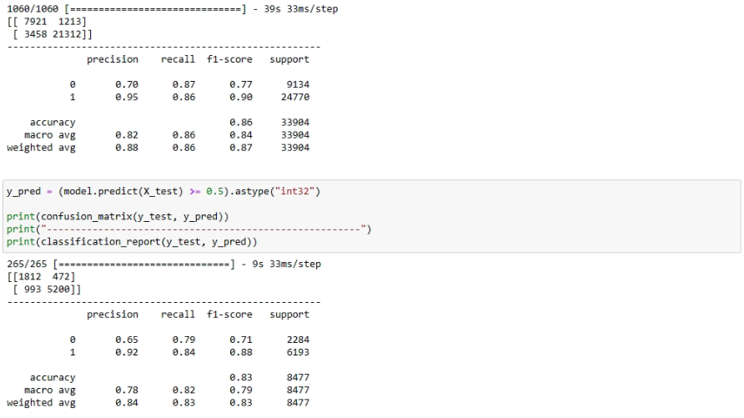

* Accuracy: 83% (proportion of correctly predicted instances out of the total وMacro Avg and Weighted Avg metrics provide additional insights, considering class distribution.

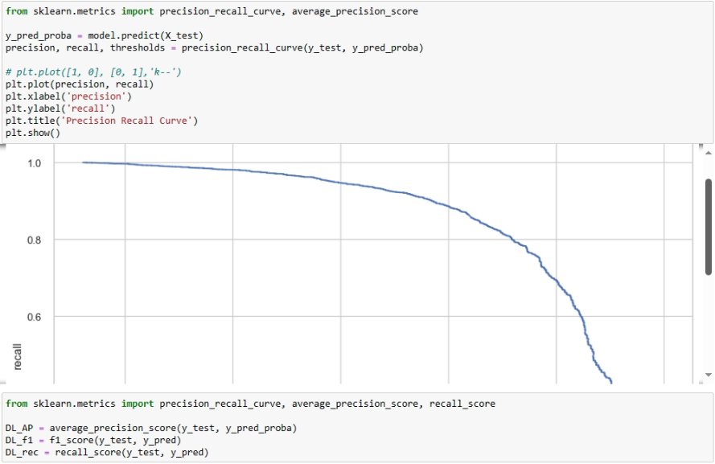

**11) PREDICTION**

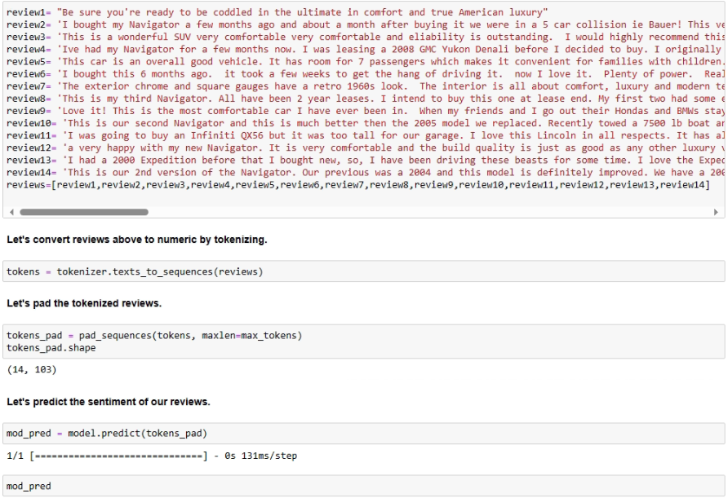

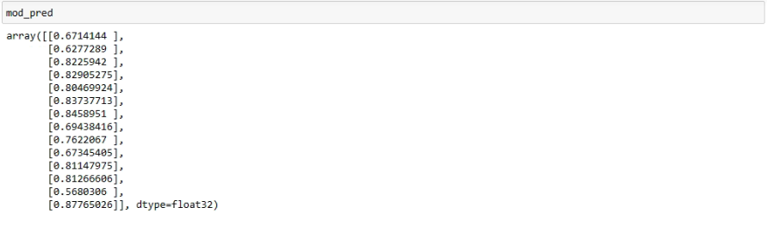

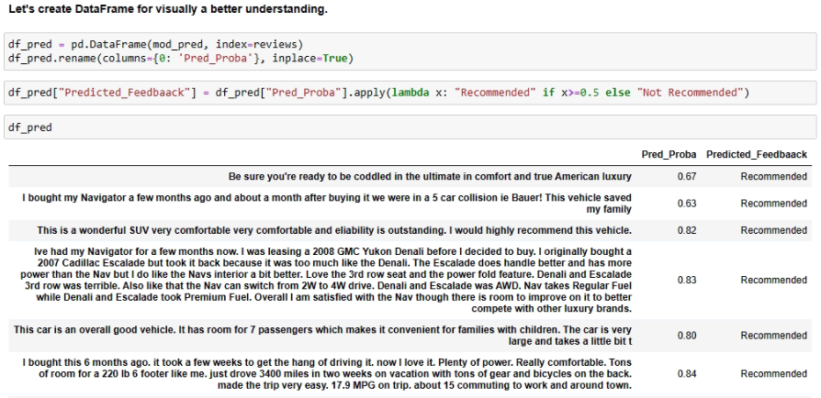

# 12) COMPARING THE MODELS

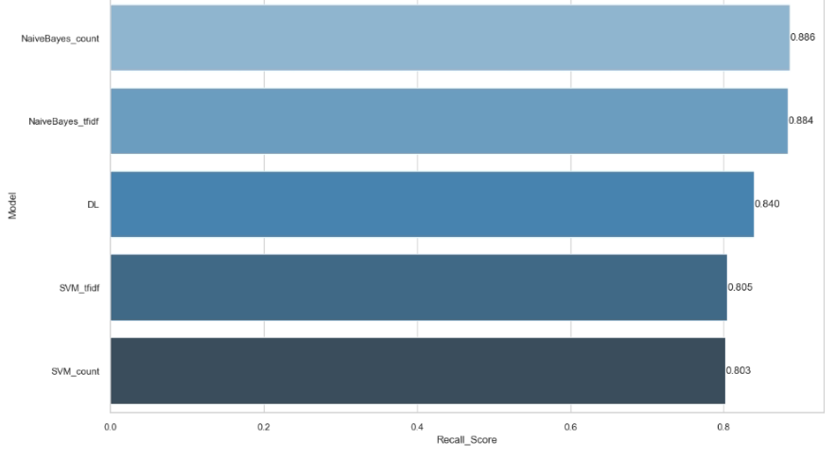

# 

# 

# 13) CONCLUSION

In this project, sentiment analysis has been employed to assess product recommendations. Various machine learning algorithms, Naive Bayes, Support Vector Machine (SVM), have been utilized to enhance prediction accuracy. Additionally, a deep learning algorithm has been incorporated for comparison purposes with the machine learning models. The dataset originates from Edmunds-Consumer Car Ratings and Reviews and is accessible on the Kaggle website at:[https://www.kaggle.com/datasets/ankkur13/edmundsconsumer-car-ratings-andreviews/data (https://www.kaggle.com/datasets/ankkur13/edmundsconsumer-car-ratingsand-reviews/data).](https://www.kaggle.com/datasets/ankkur13/edmundsconsumer-car-ratings-and-reviews/data)

In the overall comparison of models, distinguishing a clear preference among the top performing five models proves challenging due to their closely matched scores. Naïve Bayes (Count) and Naïve Bayes (TF-IDF) have the highest recall scores, indicating that they perform well in capturing positive instances. Deep Learning follows, while SVM (Count) and SVM (TF-IDF) have lower recall scores

Deep Learning has the highest F1 score, indicating a good balance between precision and recall. Naïve Bayes (Count) and Naïve Bayes (TF-IDF) follow closely, while SVM (Count) and SVM (TF-IDF) have lower F1 scores.

Also Deep Learning has the highest average precision score, indicating its ability to rank positive instances higher. SVM (Count) and Naïve Bayes (Count) follow, while Naïve Bayes (TF-IDF) and SVM (TF-IDF) have slightly lower average precision scores.

Overall Conclusion:

Best Overall Performer: Deep Learning has the highest scores in F1 and average precision, making it the best overall performer.

Naïve Bayes Strengths: Naïve Bayes performs well, particularly in recall, making it suitable when identifying positive instances is critical.

SVM Limitations: SVM, while competitive, lags slightly behind in most metrics.

Considerations:

Computational Complexity: Deep Learning models may have higher computational requirements during training. Dataset Size: The results might be influenced by the size and nature of the dataset. In summary, based on the provided metrics, Deep Learning appears to be the top-performing algorithm for sentiment analysis in this context.

However the choice of the best model also depends on specific project requirements

# 14) RECOMMINDATION

The sentiment analysis project compared various machine learning algorithms, including Naive Bayes, Support Vector Machine (SVM), and Deep Learning, using the Edmunds-Consumer Car Ratings and Reviews dataset. Here are the key findings and recommendations:

1. **Overall Performance:**
   * **Best Performer:** Deep Learning achieved the highest scores in F1 and average precision, making it the best overall performer.
   * **Naive Bayes Strengths:** Naive Bayes, especially in its Count and TF-IDF variants, excelled in recall, making it suitable for capturing positive instances.
2. **SVM Considerations:**
   * SVM, both in Count and TF-IDF, performed well but had slightly lower scores in recall and F1 compared to other models.
3. **Average Precision Scores:**
   * Deep Learning, SVM (Count), and Naive Bayes (Count) showed high average precision scores, with Deep Learning excelling in ranking positive instances.
4. **Project-Specific Decision:**
   * The choice of the best model depends on specific project requirements, considering factors such as computational complexity, dataset size, and project goals.

# 15) REFERANCES

<https://www.kaggle.com/andrewmvd/heart-failure-clinical-data>

https://scikit-learn.org/stable/modules/generated/sklearn.pipeline.Pipeline.html

<https://machinelearningmastery.com/handle-missing-data-python/>

https://en.wikipedia.org/wiki/Dummy_variable_(statistics)

https://pandas.pydata.org/docs/reference/api/pandas.read_csv.html